**A**

**Project Report**

**On**

**“Hospital management”**

**Submitted by**

**Gajbhare Adarsh Prakash**

**Class: MCA II Year**

**Guided By**

**Dr. Anagha K Joshi**



**SSBES’S**

**Institute of Technology & Management Nanded**

**Affiliated to**

**Swami Ramanand Teerth Marathwada University, Nanded**

**2022-2023**



***CERTIFICATE***

***This is to certify that the project report entitled as***

**“Hospital Management”**

**Submitted by**

**Gajbhare Adarsh Prakash**

**Class: MCA II Year**

***In partial fulfilment for the Degree of M.C.A. Course***

***at***

***“Institute of Technology and Management, Nanded”***

***Affiliated to***

***Swami Ramanand Teerth Marathwada University, Nanded.***

**2022-2023**

**Project Guide**

**Dr. Anagha K Joshi**

**Mr. M.M. Bokare Dr. S.B. Thorat**

**Head of Dept. Director**

**ACKNOWLEDGEMENT**

The success and final outcome of this project required a lot of guidance and assistance from many people and I am extremely privileged to have got this all along the completion of my project. All that I have done is only due to such supervision and assistance and I would like to extend my sincere thanks to all of them.

I am highly indebted to **Dr. Anagha K Joshi** for **Her** guidance and constant supervision as well as for providing necessary information regarding the project & also for **Her** support in completing the project.

I would like to thank **Dr. S. B. Thorat**, Director, SSBES’s Institute of Technology and Management, Nanded for providing me an opportunity to do the project work in Institute of Technology and Management, Nanded and giving us all support and guidance, which made me complete the project duly.

Also, I would like to thank **Mr. M. M. Bokare**, HOD, Dept. of Computer Science, for his encouragement and more over for their timely support and guidance till the completion of our project work.

I would like to express my gratitude towards my parents their kind co-operation and encouragement which help me in completion of this project.

My thanks and appreciations also go to my friends in developing the project and people who have willingly helped me out with their abilities.

**Gajbhare Adarsh Prakash**

**INDEX**

|  |  |  |
| --- | --- | --- |
| Sr. No | Title | Page No |
| 1 | Software Requirements Specification (SRS) E-HOSPITAL SERVICE 1 | 5 |
| 2 | Introduction | 6 |
| 3 | * 3.1 Purpose | 7 |
|  | * 3.2 Scope | 8 |
|  | * 3.3 Modules | 9 |
|  | * 3.3.2 User Module | 10 |
|  | * 3.3.3 Doctor Module | 10 |
| 3.2 | Hardware Requirements | 11 |
| 3.3 | Software Requirement | 11 |
| 4 | * Existing System | 12 |
|  | * 4.2 Proposed System | 13 |
| 5 | Conclusion | 14 |
| 6 | Project Diagram | 15 |
| 7 | User Interface | 22 |
| 10 | References | 32 |
| 11 | Code | 33 |

**Software Requirements Specification (SRS) E-HOSPITAL SERVICE 1**.

**ABSTRACT**

The purpose of the project entitled as “E-HOSPITAL SERVICE” is to computerize the Front Office Management of Hospital to develop software which is user friendly simple, fast, and cost – effective. It deals with the collection of patient’s information, diagnosis details, etc. Traditionally, it was done manually. The main function of the system is register and store patient details and doctor details and retrieve these details as and when required, and also to manipulate these details meaningfully System input contains patient details, diagnosis details, while system output is to get these details on to the screen. E-Hospital Service system can be entered using a username and password. It is accessible either by an administrator or receptionist. Only they can add data into the database. The data can be retrieved easily. The data are well protected for personal use and makes the data processing very fast.

**2. Introduction**

The project E-Hospital Service system includes registration of patients, storing their details into the system, and also computerized billing in the pharmacy, and labs. User can search availability of a doctor and the details of a patient using the name. The Hospital Management System can be entered using a username and password. It is accessible either by an administrator or receptionist. Only they can add data into the database. The data can be retrieved easily. The interface is very user-friendly. The data are well protected for personal use and makes the data processing very fast. Hospital Management System is powerful, flexible, and easy to use and is designed and developed to deliver real conceivable benefits to hospitals. Hospital Management System is designed for multi-speciality hospitals, to cover a wide range of hospital administration and management processes. It is an integrated end to-end Hospital Management System that provides relevant information across the hospital to support effective decision making for patient care, hospital administration and critical financial accounting, in a seamless flow. E-Hospital Management System is a software product suite designed to improve the quality and management of hospital management in the areas of clinical process analysis and activity-based costing. Hospital Management System enables you to develop your organization and improve its effectiveness and quality of work

**3.1 Purpose**

1) Define hospital and doctors’ information.

2) Recording information about the Patients that come.

3) Generating bills.

4) Recording information related to diagnosis given to patients.

5) Keeping record of the immunization provided to children/patients.

6) Keeping information about various diseases and medicines available to cure them. These are the various jobs that need to be done in a hospital by the operational staff and Doctors.

**3.2 Scope**

1) Information about Patients is done by just writing the Patients name, age and gender. Whenever the Patient comes up his information is stored freshly.

2) Bills are generated by recording price for each facility provided to patient on a separate sheet and at last they all are summed up.

3) Diagnosis information to patients is generally recorded on the document, which contains Patient information. It is destroyed after some time period to decrease the paper load in the office.

4) Immunization records of children are maintained in pre-formatted sheets, which are kept in a file.

5) Information about various diseases is not kept as any document. Doctors themselves do this job by remembering various medicines.

**3.3 MODULES:**

The entire project mainly consists of 3 modules, which are

❖ Admin module

❖ User module (patient)

❖ Doctor module 3.3.1

**Admin module:**

▪ manage department of hospitals, user, doctor, pharmacist accounts.

▪ watch appointment of doctors.

▪ watch transaction reports of patient payment.

▪ watch medicine status of hospital stock.

**3.3.2 User module(patient):**

▪ View appointment list and status with doctors.

▪ View prescription details.

▪ View medication from doctor View doctor list

▪ Manage own profile

**3.3.3 Doctor module:**

▪ Manage patient. account opening and updating.

▪ Create, manage appointment with patient.

▪ Create prescription for patient.

▪ Provide medication for patients.

▪ Manage own profile.

**3.2 HARDWARE REQUIREMENTS:**

**HARDWARE REQUIREMENTS FOR PRESENT PROJECT:**

**PROCESSOR**: Intel dual Core, i3

**RAM:** 4 GB HARD

**DISK:** 1 TB

**3.4 SOFTWARE REQUIREMENTS:**

**SOFTWARE REQUIREMENTS FOR PRESENT PROJECT:**

**OPERATING SYSTEM:** Windows 10

**FRONT END:** HTML, CSS, JAVASCRIPT.

**SERVER-SIDE** **SCRIPT:** PHP

**DATABASE:** MYSQL

**4.1 EXISTING SYSTEM:**

Hospitals currently use a manual system for the management and maintenance of critical information. The current system requires numerous paper forms, with data stores spread throughout the hospital management infrastructure. Often information is incomplete or does not follow management standards. Forms are often lost in transit between departments requiring a comprehensive auditing process to ensure that no vital information is lost. Multiple copies of the same information exist in the hospital and may lead to inconsistencies in data in various data stores.

**4.2 PROPOSED SYSTEM:**

The Hospital Management System is designed for any hospital to replace their existing manual paper-based system. The new system is to control the information of patients. Room availability, staff and operating room schedules and patient invoices. These services are to be provided in an efficient, cost-effective manner, with the goal of reducing the time and resources currently required for such tasks.

**5.CONCLUSION:**

Since we are entering details of the patients electronically in the” Hospital Service”, data will be secured. Using this website, we can retrieve patient’s history with a single click. Thus, processing information will be faster. It guarantees accurate maintenance of patient details. It easily reduces the book keeping task and thus reduces the human effort and increases accuracy speed.

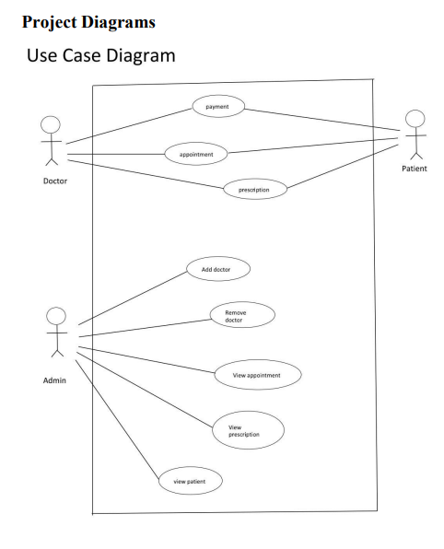

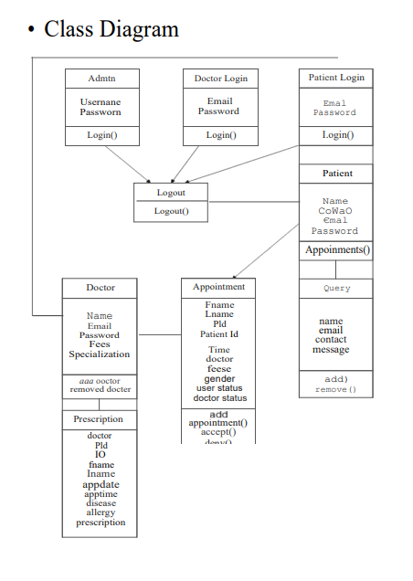

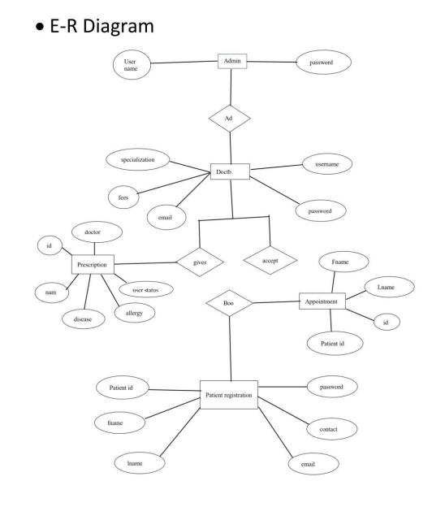

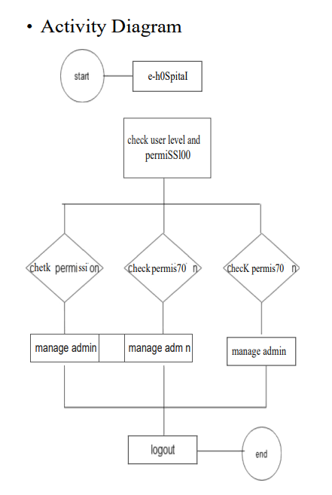

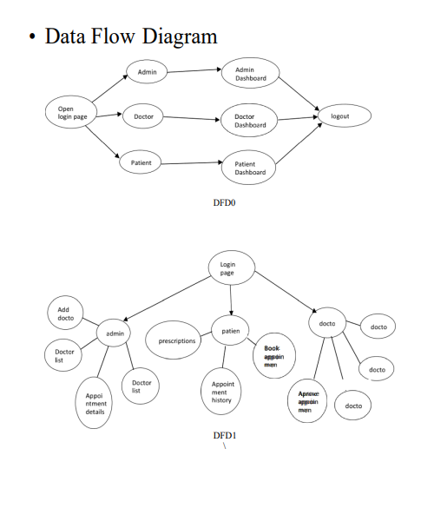

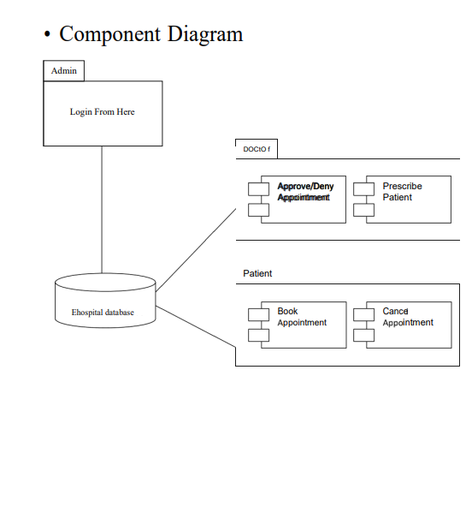

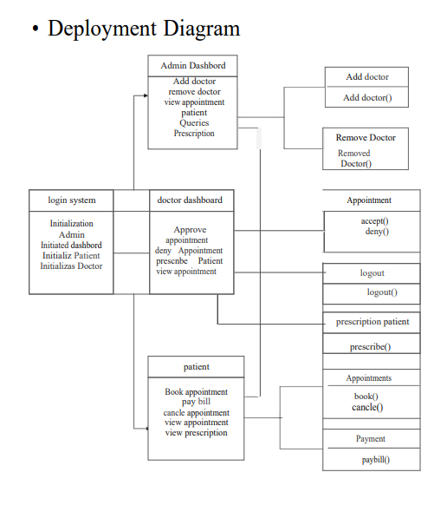

**7.User Interface:**

**Home Page:**

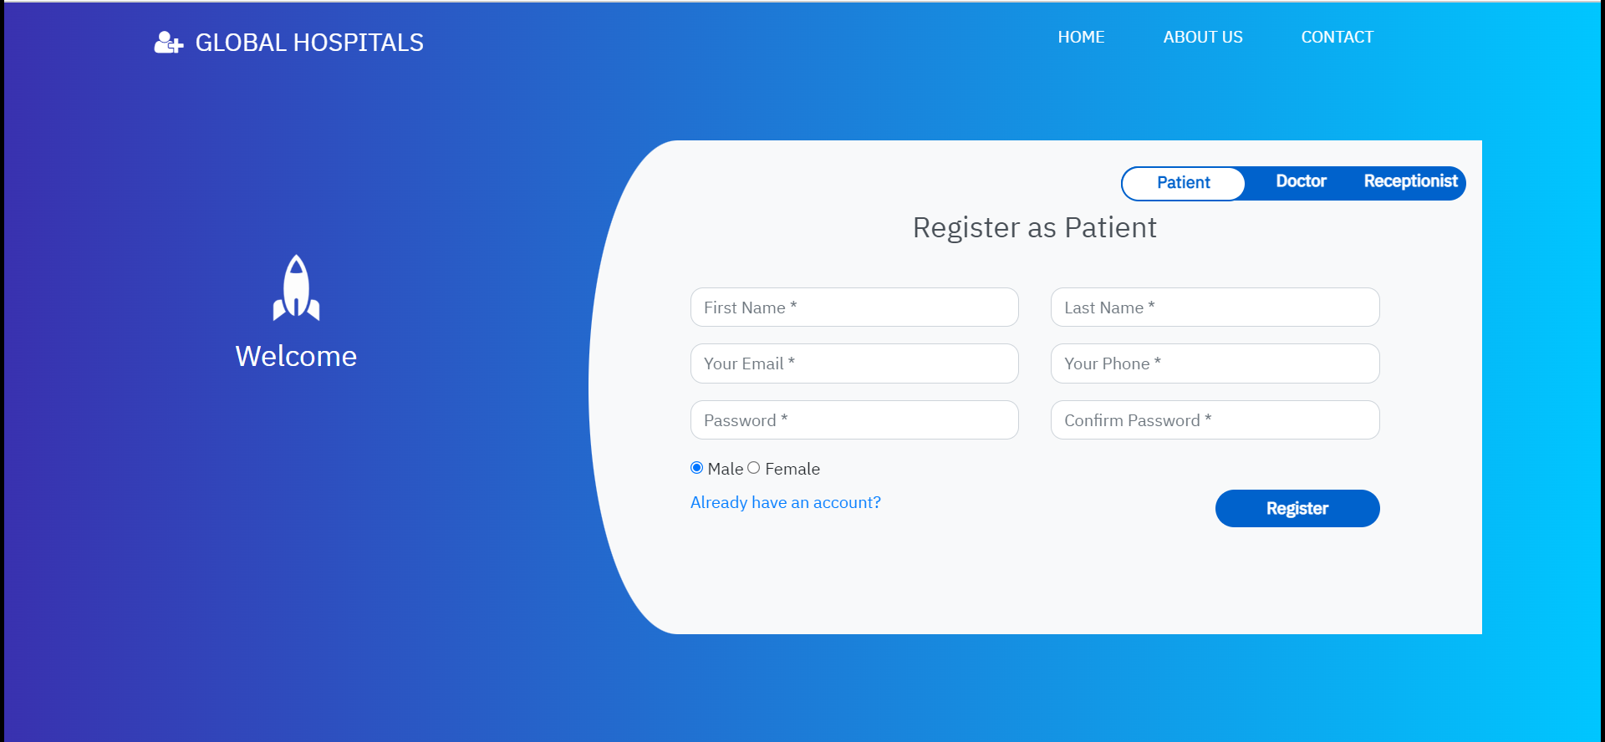

**Patient login page: -**

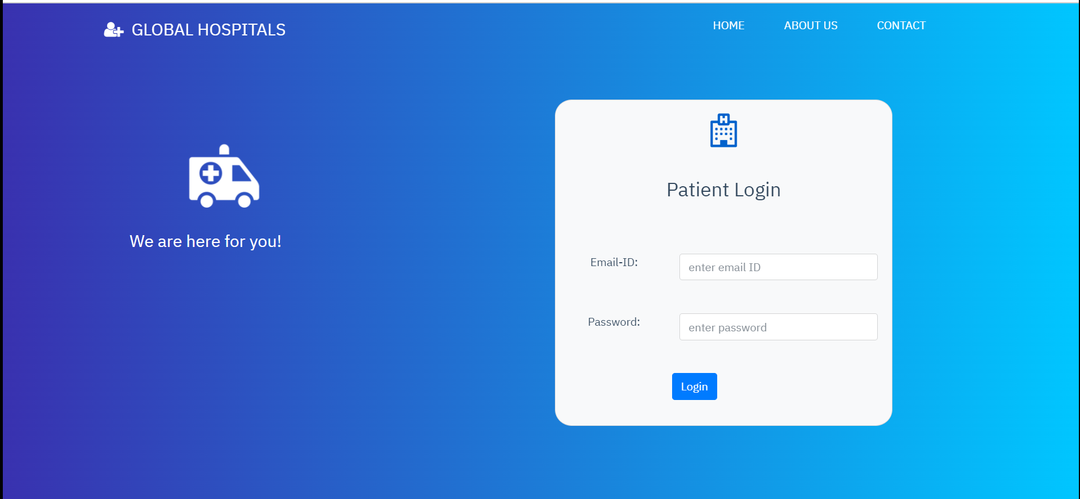

**Patient appointment page: -**

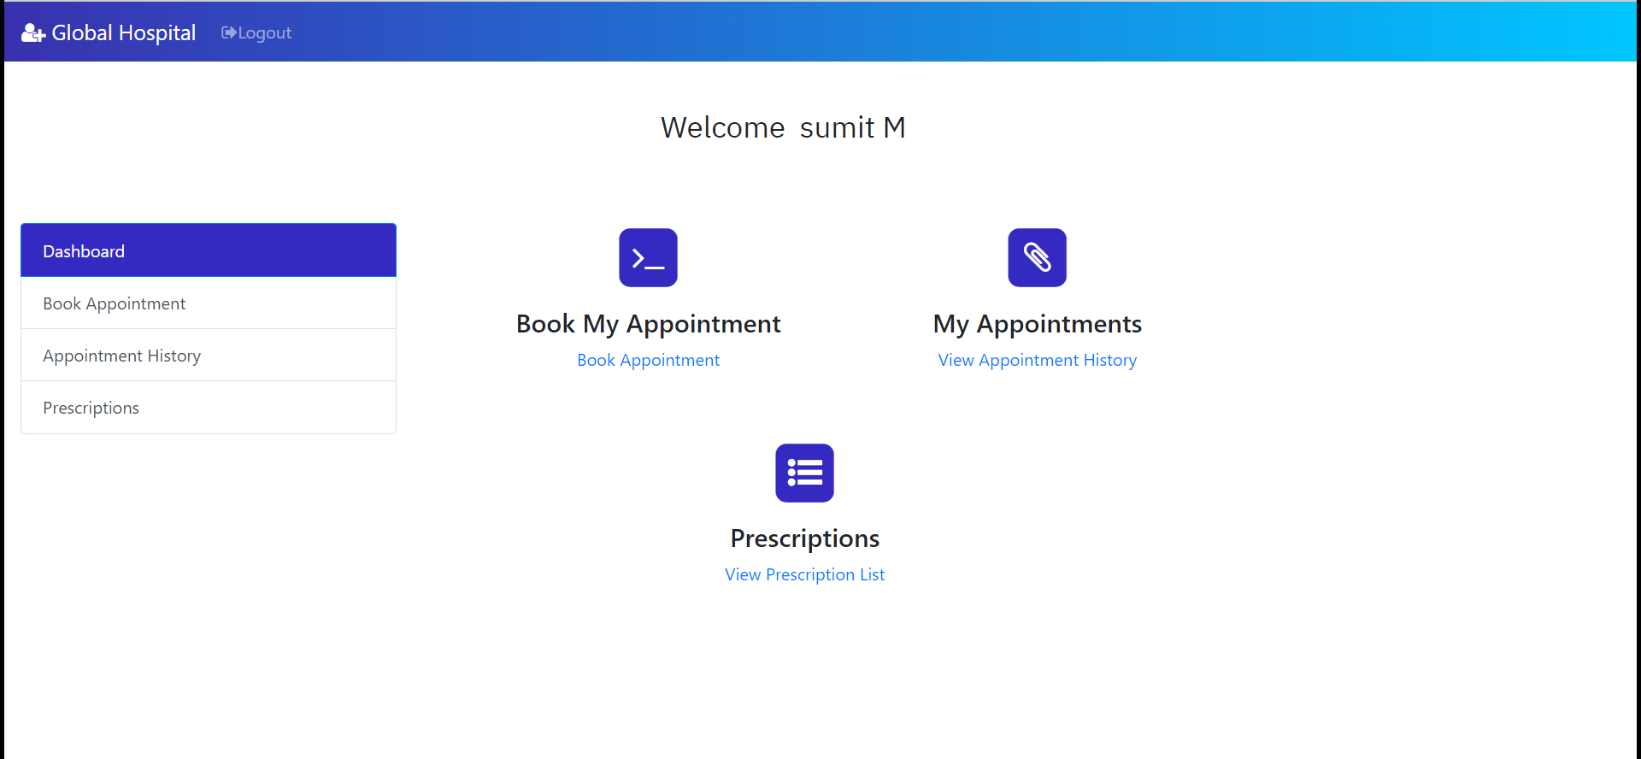

**Book Appointment: -**

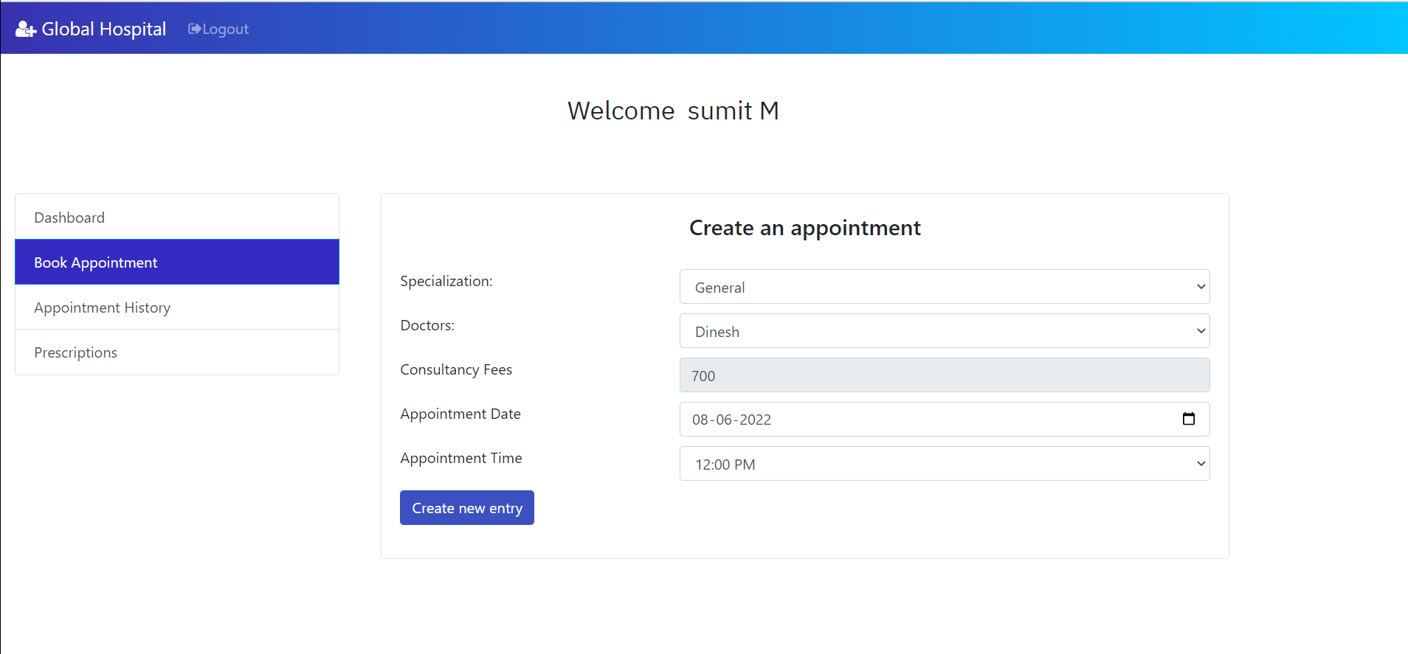

**Appointment history: -**

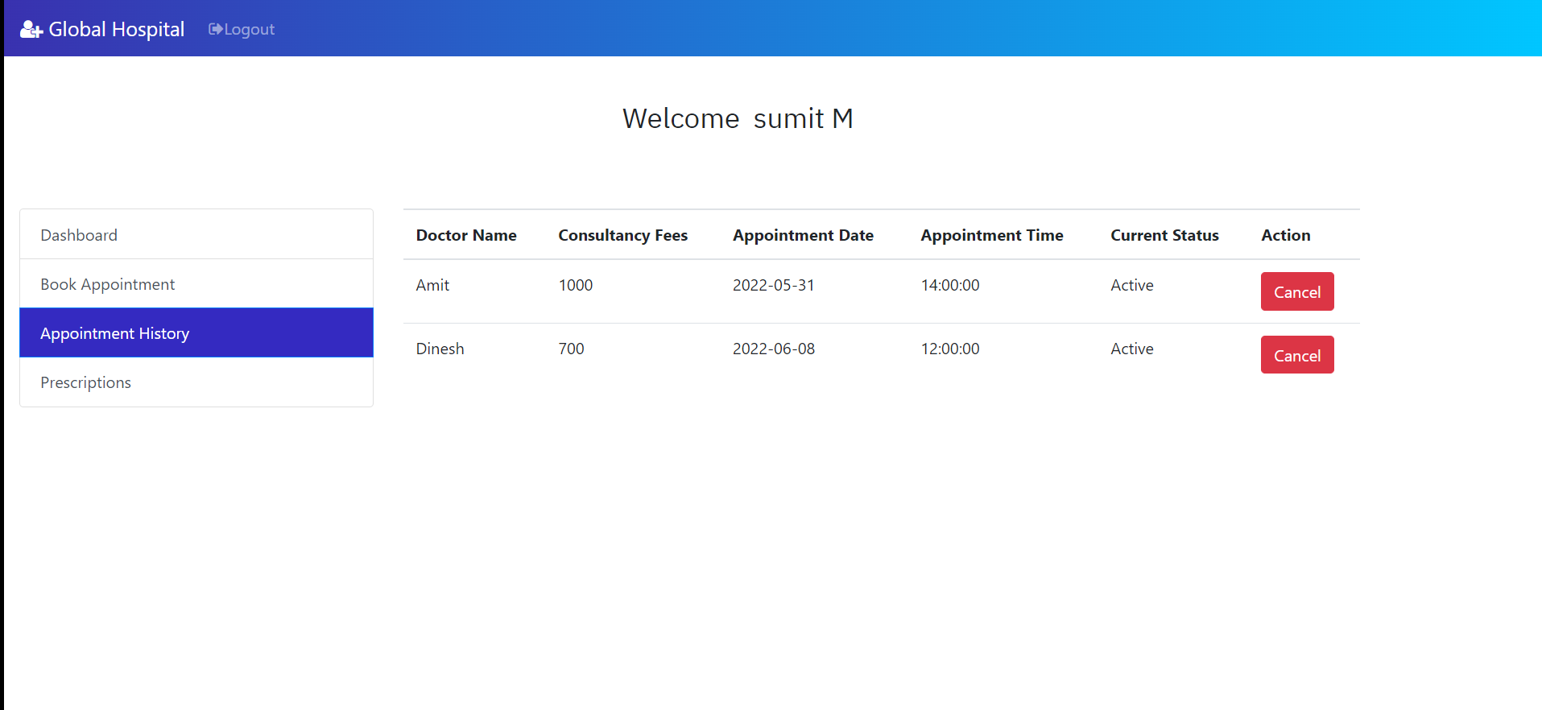

**Prescriptions: -**

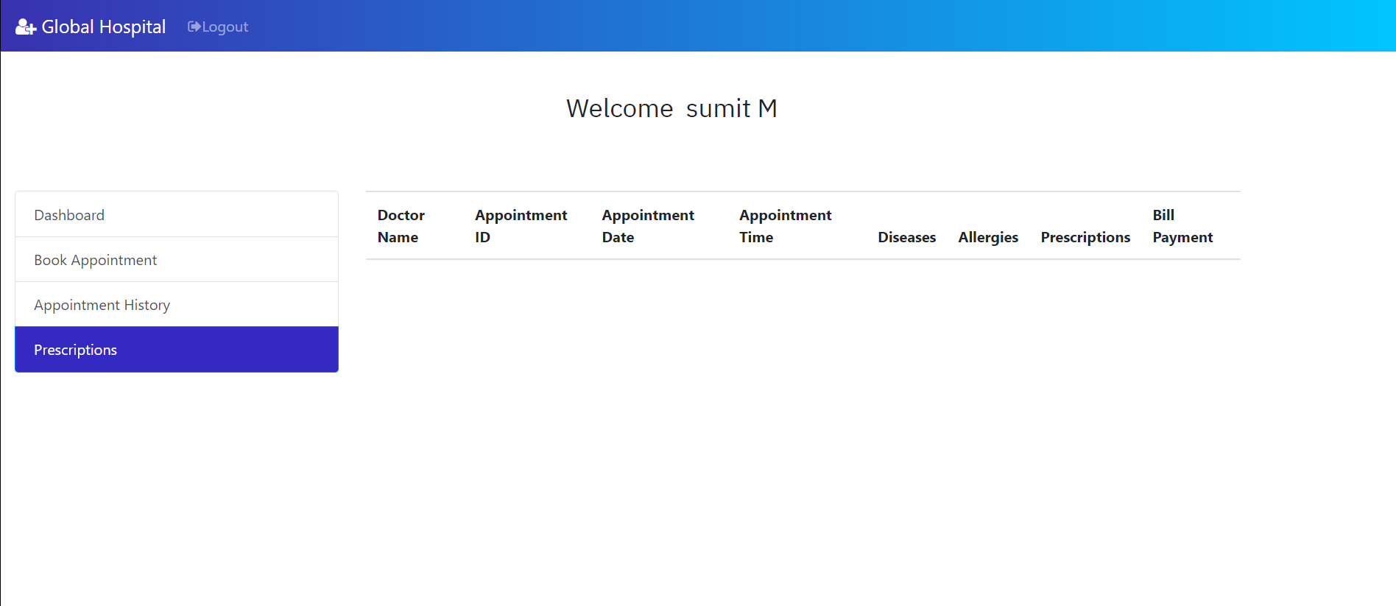

**Doctors Login: -**

**Login page: -**

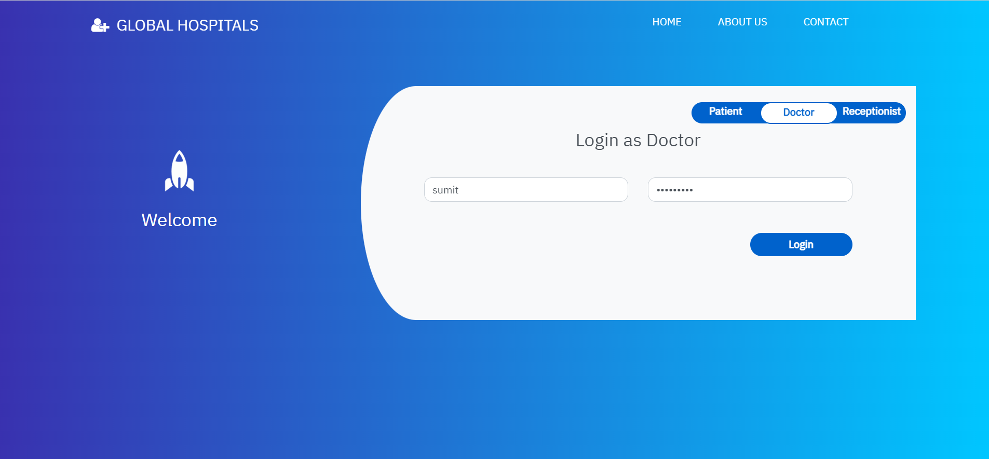

**Dashboard: -**

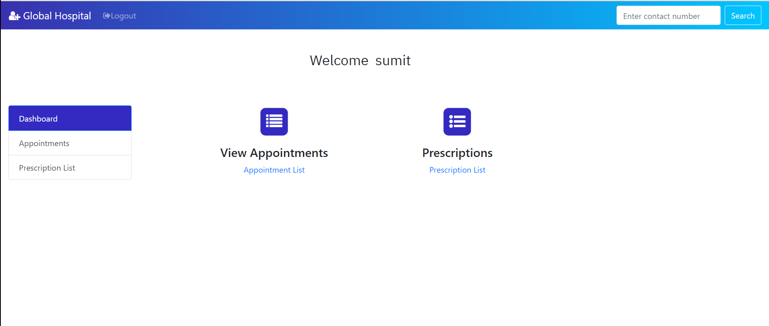

**Appointment: -**

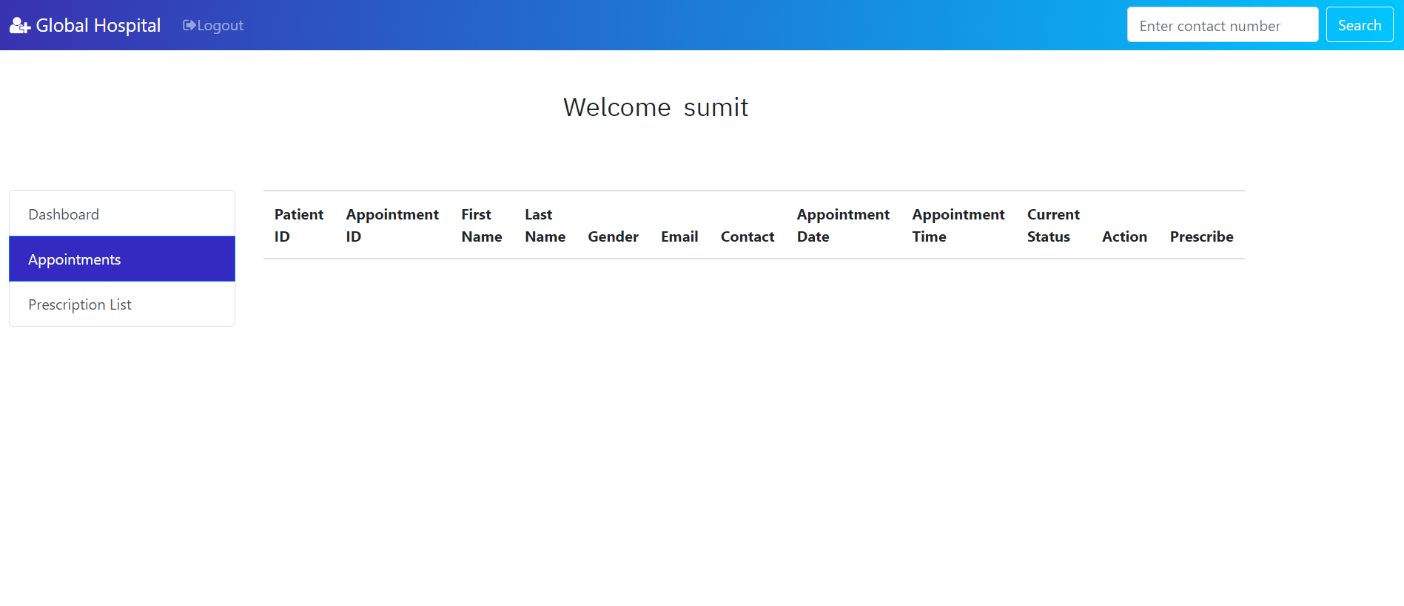

**Prescription: -**

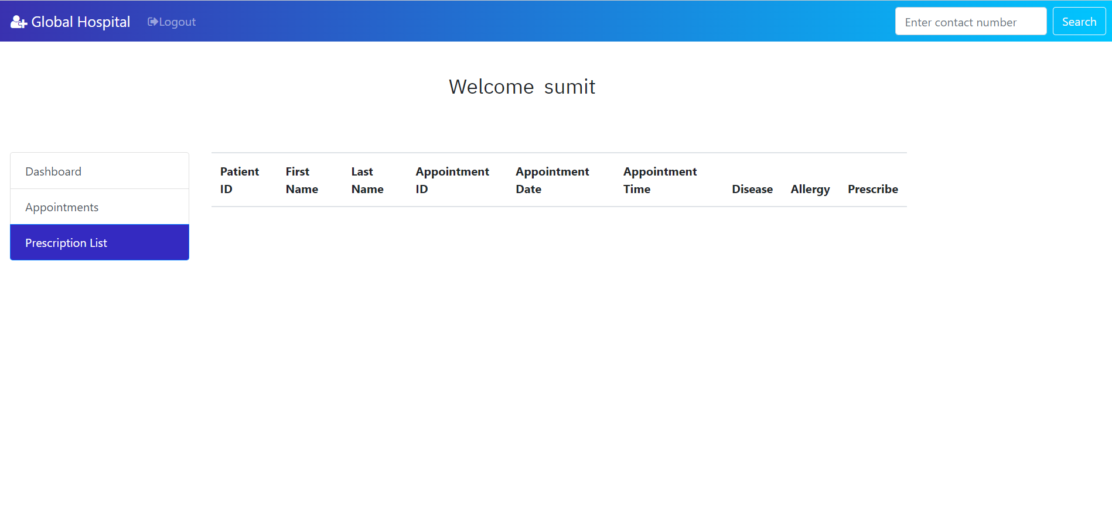

**Admin Page: -**

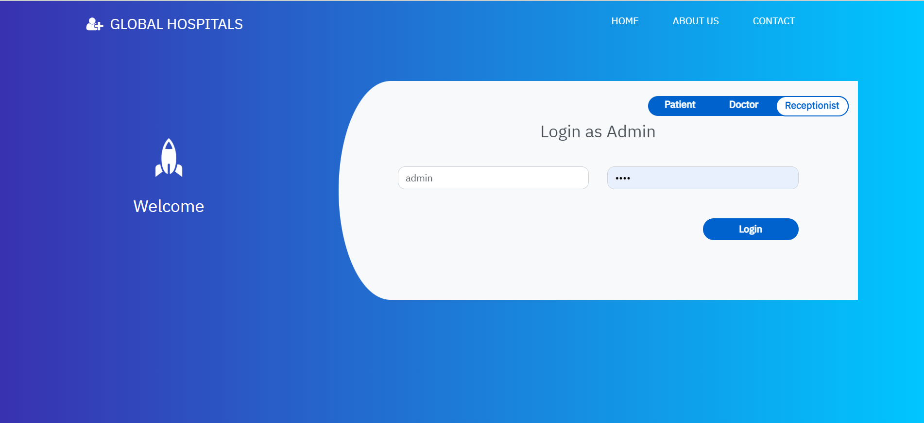

1. **Dashboard: -**

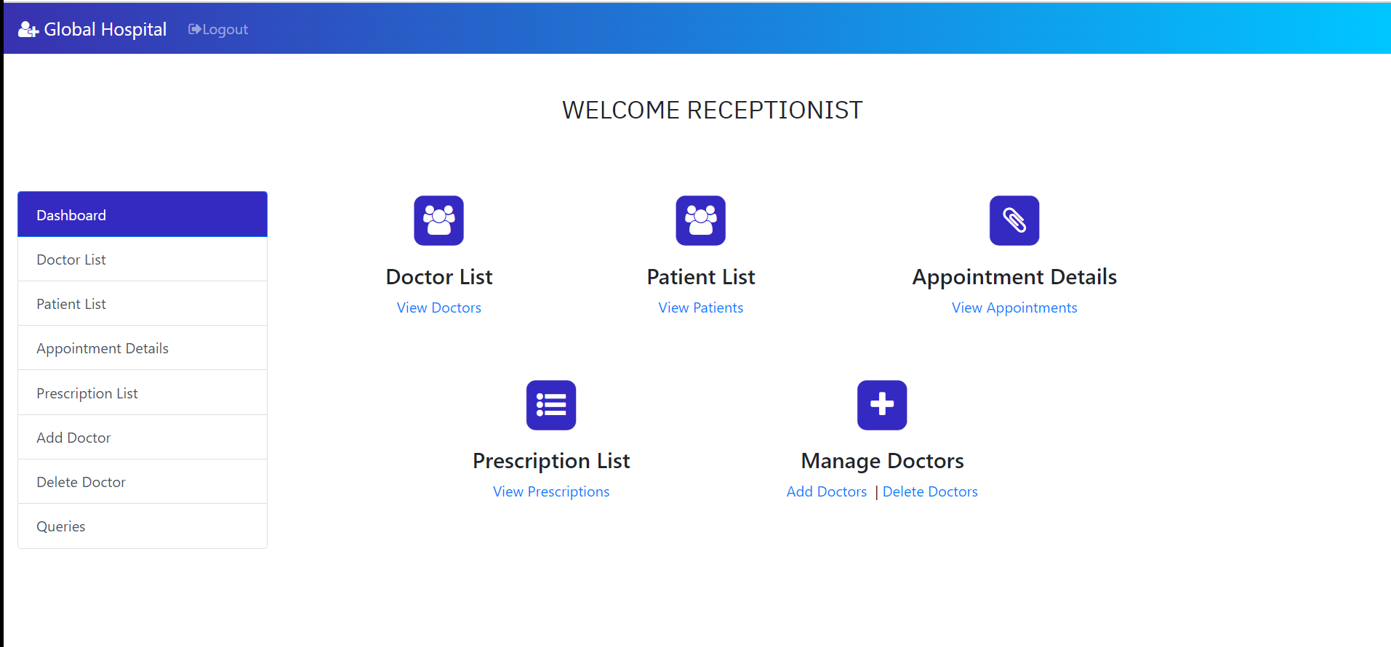

1. **Doctor list: -**

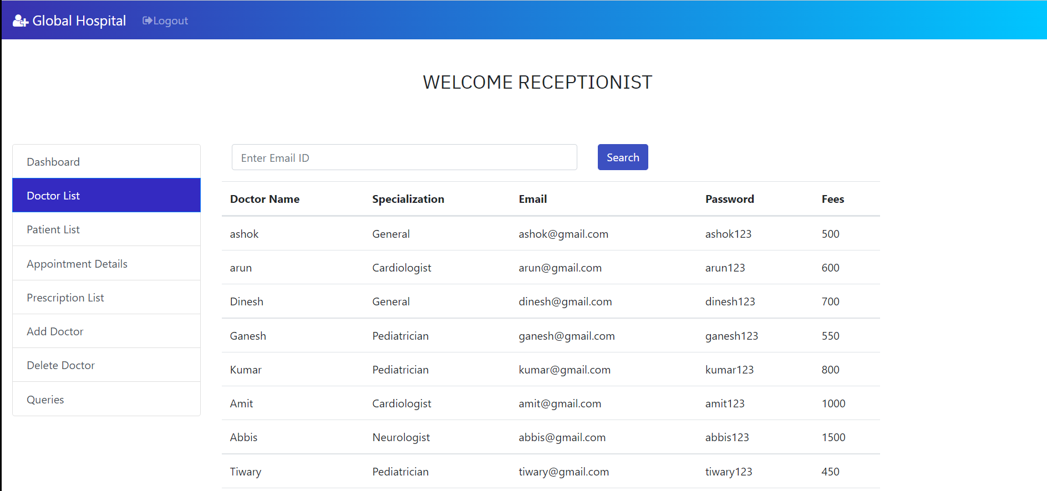

1. **Patient list:**

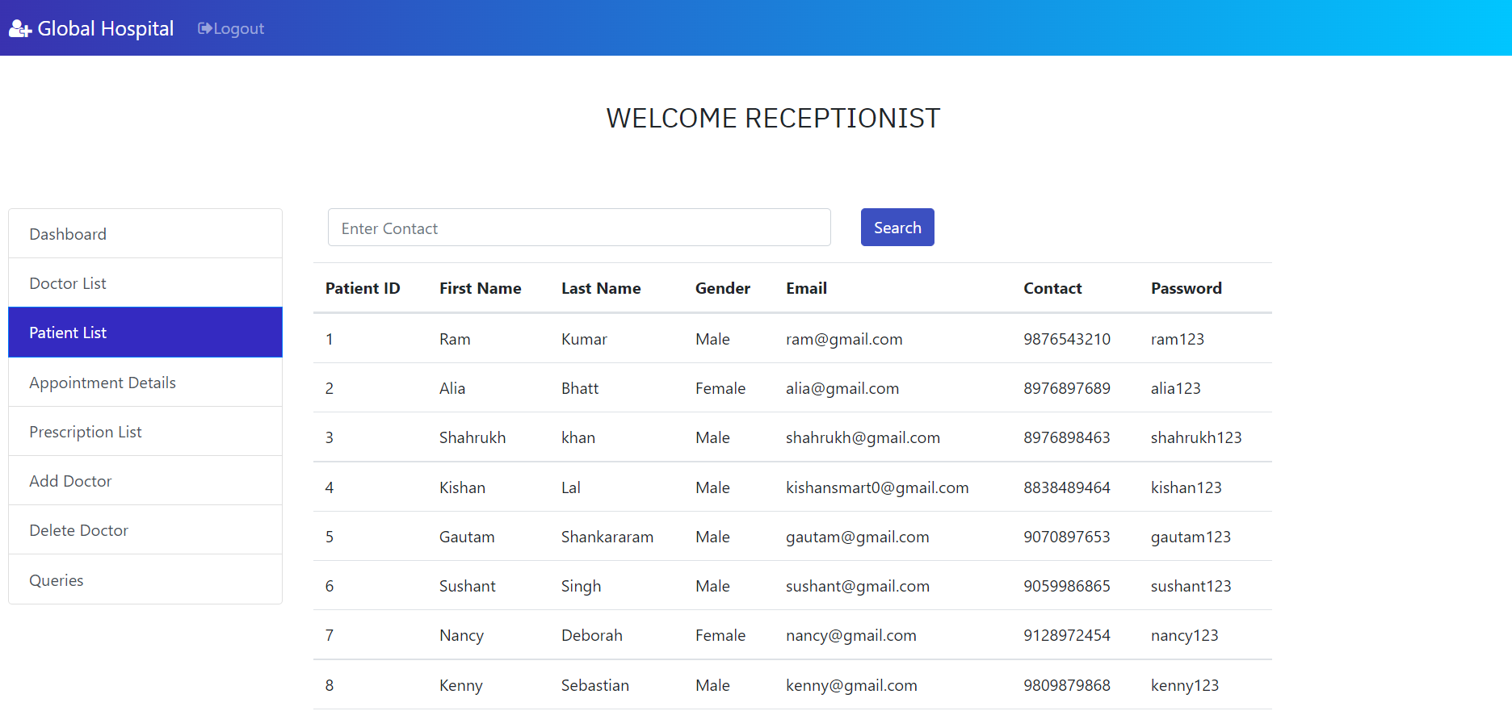

1. **Appointment details: -**

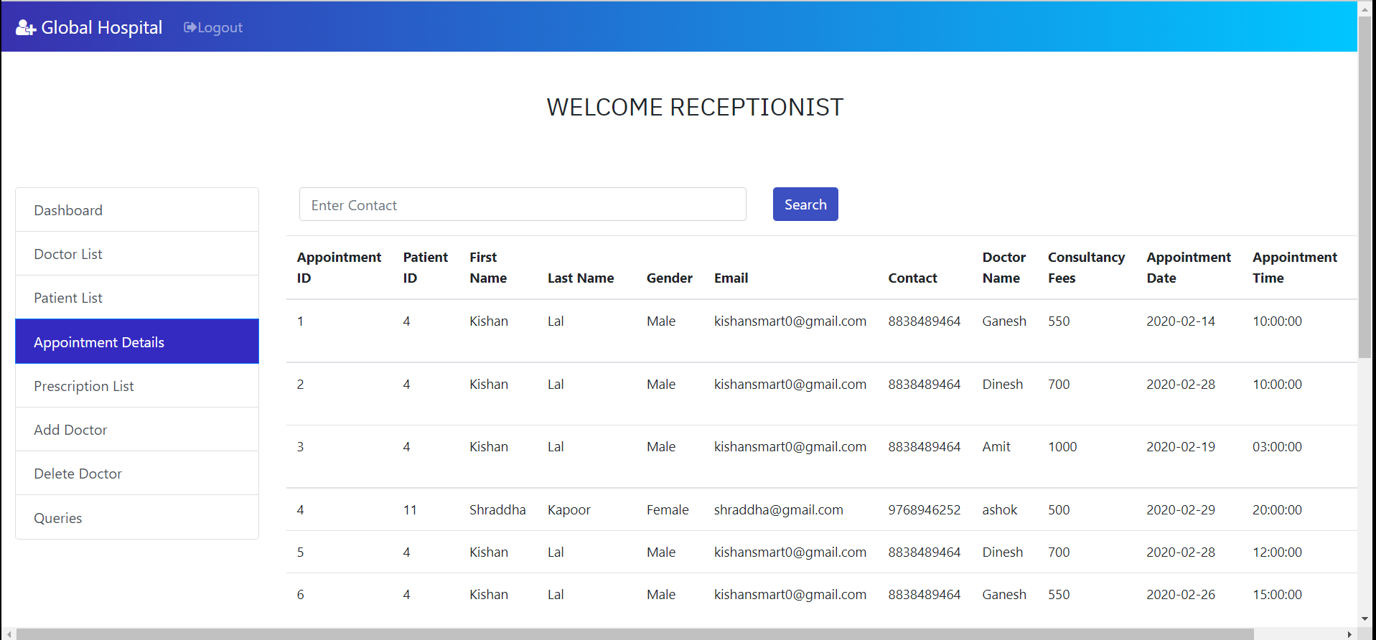

1. **Add doctors: -**

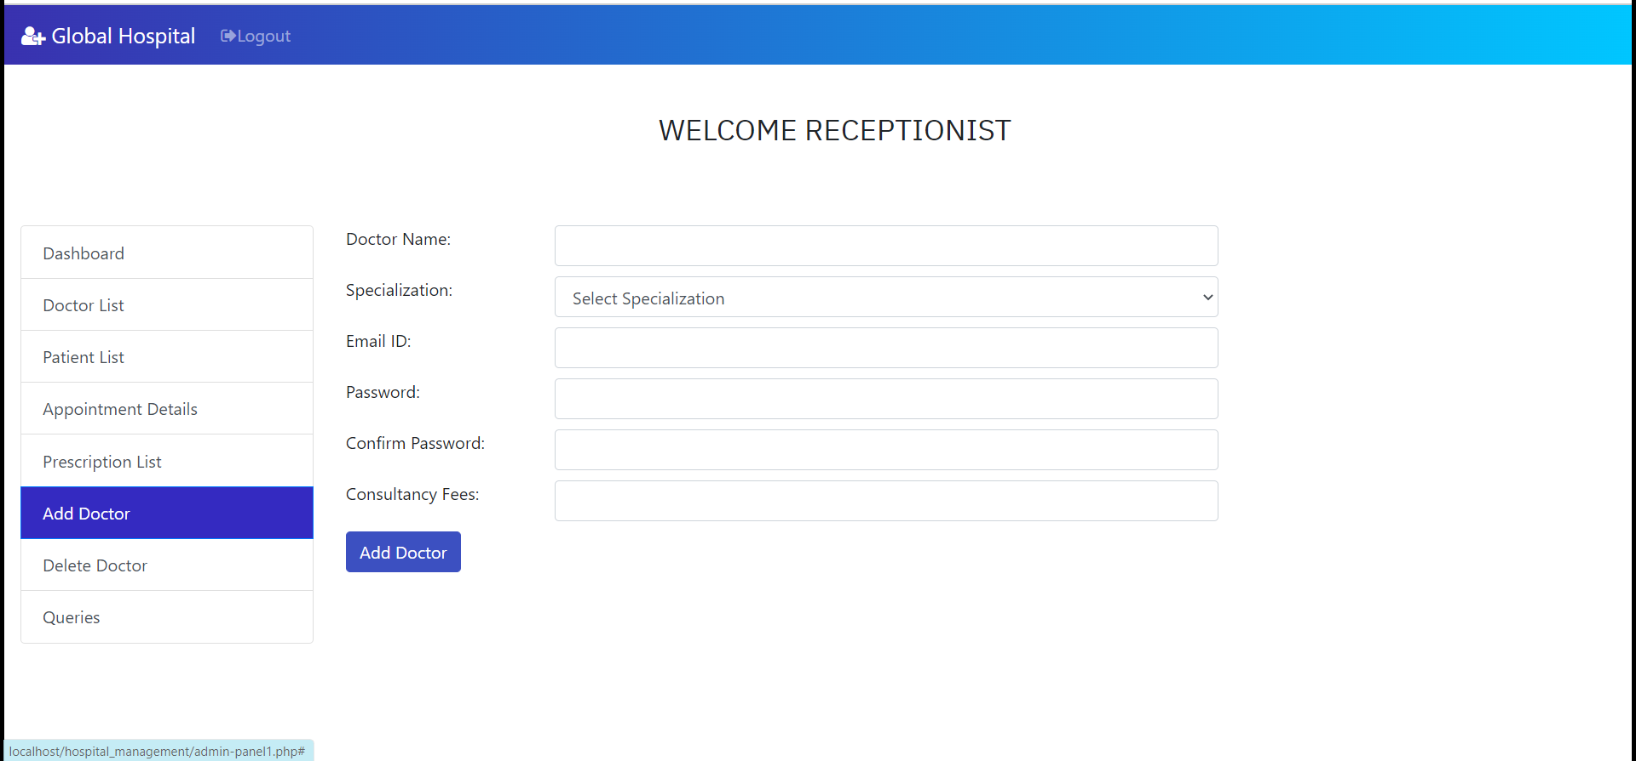

1. **Delete doctor: -**

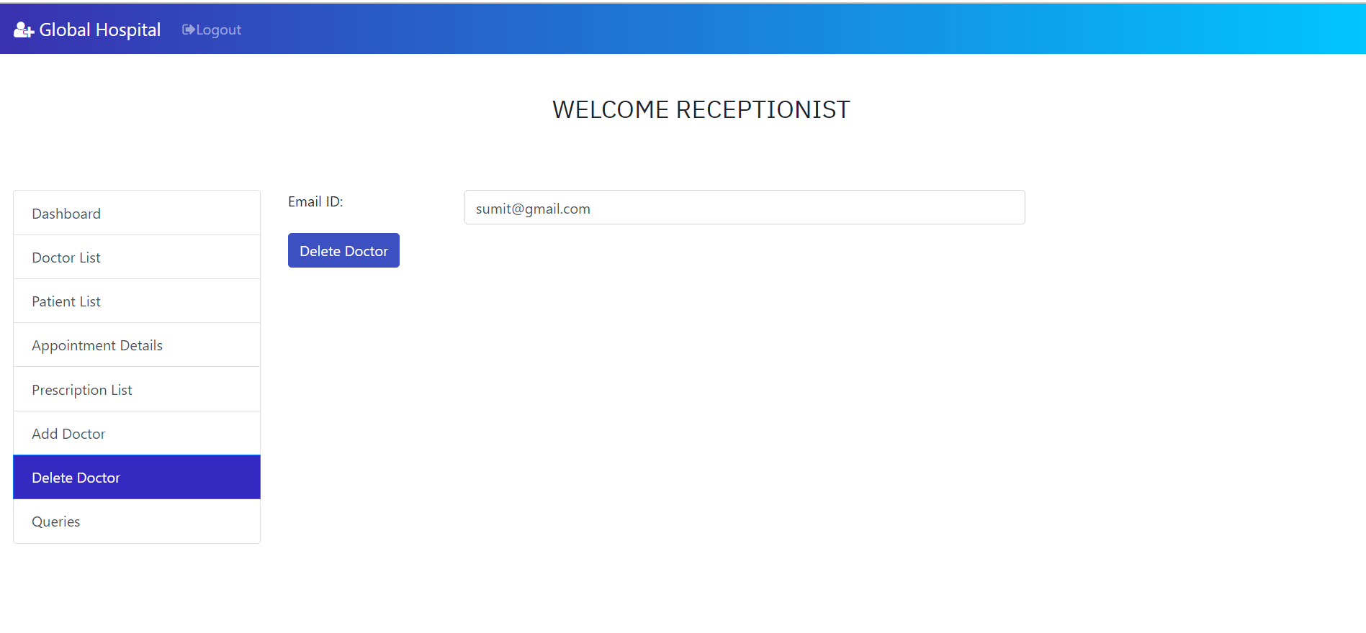

1. **Queries: -**

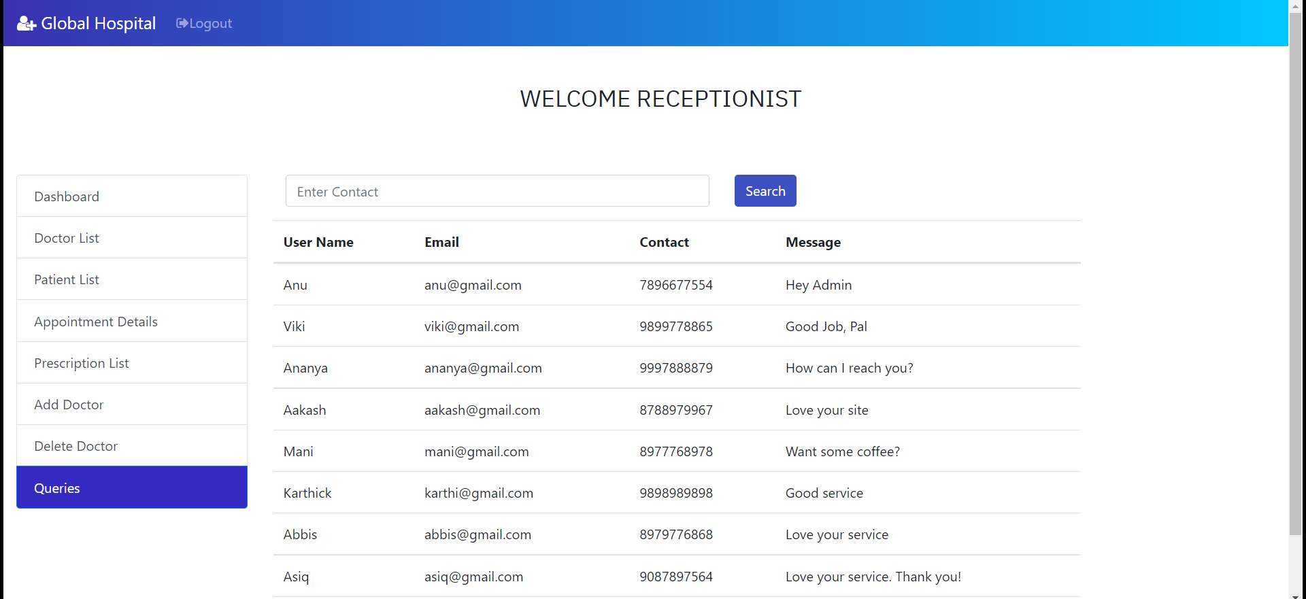

**6.REFERENCE**

1. PHP MySQL Website Programming: Problem - Design – Solution by Chris Lea, Mike Buzzard, Dilip Thomas, Jessey White-Cinis

2. Beginning PHP5, Apache, and MySQL Web Development (Programmer to Programmer) by Elizabeth Naramore

3. MySQL/PHP Database Applications, 2nd Edition by Brad Bulger

4. How to Do Everything with PHP and MySQL by Vikram Vaswani.

**Registration page**

<html>

<head>

    <title>HMS</title>

    <link rel="shortcut icon" type="image/x-icon" href="images/favicon.png" />

<link rel="stylesheet" type="text/css" href="style1.css">

<link href="https://fonts.googleapis.com/css?family=IBM+Plex+Sans&display=swap" rel="stylesheet">

<!-- <link rel="stylesheet" href="https://stackpath.bootstrapcdn.com/bootstrap/3.4.1/css/bootstrap.min.css" integrity="sha384-HSMxcRTRxnN+Bdg0JdbxYKrThecOKuH5zCYotlSAcp1+c8xmyTe9GYg1l9a69psu" crossorigin="anonymous"> -->

<link rel="stylesheet" href="https://stackpath.bootstrapcdn.com/bootstrap/4.3.1/css/bootstrap.min.css" integrity="sha384-ggOyR0iXCbMQv3Xipma34MD+dH/1fQ784/j6cY/iJTQUOhcWr7x9JvoRxT2MZw1T" crossorigin="anonymous">

<link rel="stylesheet" href="vendor/fontawesome/css/font-awesome.min.css">

<link href="//maxcdn.bootstrapcdn.com/bootstrap/4.1.1/css/bootstrap.min.css" rel="stylesheet" id="bootstrap-css">

<style >

     .form-control {

    border-radius: 0.75rem;

}

</style>

<script>

    var check = function() {

  if (document.getElementById('password').value ==

    document.getElementById('cpassword').value) {

    document.getElementById('message').style.color = '#5dd05d';

    document.getElementById('message').innerHTML = 'Matched';

  } else {

    document.getElementById('message').style.color = '#f55252';

    document.getElementById('message').innerHTML = 'Not Matching';

  }

}

function alphaOnly(event) {

  var key = event.keyCode;

  return ((key >= 65 && key <= 90) || key == 8 || key == 32);

};

function checklen()

{

    var pass1 = document.getElementById("password");

    if(pass1.value.length<6){

        alert("Password must be at least 6 characters long. Try again!");

        return false;

  }

}

</script>

</head>

<!------ Include the above in your HEAD tag ---------->

<body>

<nav class="navbar navbar-expand-lg navbar-dark fixed-top" id="mainNav" >

    <div class="container">

      <a class="navbar-brand js-scroll-trigger" href="#" style="margin-top: 10px;margin-left:-65px;font-family: 'IBM Plex Sans', sans-serif;"><h4><i class="fa fa-user-plus" aria-hidden="true"></i>&nbsp GLOBAL HOSPITALS</h4></a>

      <button class="navbar-toggler" type="button" data-toggle="collapse" data-target="#navbarResponsive" aria-controls="navbarResponsive" aria-expanded="false" aria-label="Toggle navigation">

        <span class="navbar-toggler-icon"></span>

      </button>

      <div class="collapse navbar-collapse" id="navbarResponsive">

        <ul class="navbar-nav ml-auto">

          <li class="nav-item" style="margin-right: 40px;">

            <a class="nav-link js-scroll-trigger" href="index.php" style="color: white;font-family: 'IBM Plex Sans', sans-serif;"><h6>HOME</h6></a>

          </li>

          <li class="nav-item" style="margin-right: 40px;">

            <a class="nav-link js-scroll-trigger" href="services.html" style="color: white;font-family: 'IBM Plex Sans', sans-serif;"><h6>ABOUT US</h6></a>

          </li>

          <li class="nav-item">

            <a class="nav-link js-scroll-trigger" href="contact.html" style="color: white;font-family: 'IBM Plex Sans', sans-serif;"><h6>CONTACT</h6></a>

          </li>

        </ul>

      </div>

    </div>

  </nav>

<div class="container register" style="font-family: 'IBM Plex Sans', sans-serif;">

                <div class="row">

                    <div class="col-md-3 register-left" style="margin-top: 10%;right: 5%">

                        <img src="https://image.ibb.co/n7oTvU/logo_white.png" alt=""/>

                        <h3>Welcome</h3>

                    </div>

                    <div class="col-md-9 register-right" style="margin-top: 40px;left: 80px;">

                        <ul class="nav nav-tabs nav-justified" id="myTab" role="tablist" style="width: 40%;">

                            <li class="nav-item">

                                <a class="nav-link active" id="home-tab" data-toggle="tab" href="#home" role="tab" aria-controls="home" aria-selected="true">Patient</a>

                            </li>

                            <li class="nav-item">

                                <a class="nav-link" id="profile-tab" data-toggle="tab" href="#profile" role="tab" aria-controls="profile" aria-selected="false">Doctor</a>

                            </li>

                            <li class="nav-item">

                                <a class="nav-link" id="profile-tab" data-toggle="tab" href="#admin" role="tab" aria-controls="admin" aria-selected="false">Receptionist</a>

                            </li>

                        </ul>

                        <div class="tab-content" id="myTabContent">

                            <div class="tab-pane fade show active" id="home" role="tabpanel" aria-labelledby="home-tab">

                                <h3 class="register-heading">Register as Patient</h3>

                                <form method="post" action="func2.php">

                                <div class="row register-form">

                                    <div class="col-md-6">

                                        <div class="form-group">

                                            <input type="text" class="form-control"  placeholder="First Name *" name="fname"  onkeydown="return alphaOnly(event);" required/>

                                        </div>

                                        <div class="form-group">

                                            <input type="email" class="form-control" placeholder="Your Email *" name="email"  />

                                        </div>

                                        <div class="form-group">

                                            <input type="password" class="form-control" placeholder="Password *" id="password" name="password" onkeyup='check();' required/>

                                        </div>

                                        <div class="form-group">

                                            <div class="maxl">

                                                <label class="radio inline">

                                                    <input type="radio" name="gender" value="Male" checked>

                                                    <span> Male </span>

                                                </label>

                                                <label class="radio inline">

                                                    <input type="radio" name="gender" value="Female">

                                                    <span>Female </span>

                                                </label>

                                            </div>

                                            <a href="index1.php">Already have an account?</a>

                                        </div>

                                    </div>

                                    <div class="col-md-6">

                                        <div class="form-group">

                                            <input type="text" class="form-control" placeholder="Last Name *" name="lname" onkeydown="return alphaOnly(event);" required/>

                                        </div>

                                        <div class="form-group">

                                            <input type="tel" minlength="10" maxlength="10" name="contact" class="form-control" placeholder="Your Phone *"  />

                                        </div>

                                        <div class="form-group">

                                            <input type="password" class="form-control"  id="cpassword" placeholder="Confirm Password *" name="cpassword"  onkeyup='check();' required/><span id='message'></span>

                                        </div>

                                        <input type="submit" class="btnRegister" name="patsub1" onclick="return checklen();" value="Register"/>

                                    </div>

                                </div>

                            </form>

                            </div>

                            <div class="tab-pane fade show" id="profile" role="tabpanel" aria-labelledby="profile-tab">

                                <h3  class="register-heading">Login as Doctor</h3>

                                <form method="post" action="func1.php">

                                <div class="row register-form">

                                    <div class="col-md-6">

                                        <div class="form-group">

                                            <input type="text" class="form-control" placeholder="User Name *" name="username3" onkeydown="return alphaOnly(event);" required/>

                                        </div>

                                    </div>

                                    <div class="col-md-6">

                                        <div class="form-group">

                                            <input type="password" class="form-control" placeholder="Password *" name="password3" required/>

                                        </div>

                                        <input type="submit" class="btnRegister" name="docsub1" value="Login"/>

                                    </div>

                                </div>

                            </form>

                            </div>

                            <div class="tab-pane fade show" id="admin" role="tabpanel" aria-labelledby="profile-tab">

                                <h3  class="register-heading">Login as Admin</h3>

                                <form method="post" action="func3.php">

                                <div class="row register-form">

                                    <div class="col-md-6">

                                        <div class="form-group">

                                            <input type="text" class="form-control" placeholder="User Name *" name="username1" onkeydown="return alphaOnly(event);" required/>

                                        </div>

                                    </div>

                                    <div class="col-md-6">

                                        <div class="form-group">

                                            <input type="password" class="form-control" placeholder="Password *" name="password2" required/>

                                        </div>

                                        <input type="submit" class="btnRegister" name="adsub" value="Login"/>

                                    </div>

                                </div>

                            </form>

                            </div>

                        </div>

                    </div>

                </div>

            </div>

    </body>

    <script src="https://code.jquery.com/jquery-3.3.1.slim.min.js" integrity="sha384-q8i/X+965DzO0rT7abK41JStQIAqVgRVzpbzo5smXKp4YfRvH+8abtTE1Pi6jizo" crossorigin="anonymous"></script>

<script src="https://cdnjs.cloudflare.com/ajax/libs/popper.js/1.14.7/umd/popper.min.js" integrity="sha384-UO2eT0CpHqdSJQ6hJty5KVphtPhzWj9WO1clHTMGa3JDZwrnQq4sF86dIHNDz0W1" crossorigin="anonymous"></script>

<script src="https://stackpath.bootstrapcdn.com/bootstrap/4.3.1/js/bootstrap.min.js" integrity="sha384-JjSmVgyd0p3pXB1rRibZUAYoIIy6OrQ6VrjIEaFf/nJGzIxFDsf4x0xIM+B07jRM" crossorigin="anonymous"></script>

<script src="https://stackpath.bootstrapcdn.com/bootstrap/3.4.1/js/bootstrap.min.js" integrity="sha384-aJ21OjlMXNL5UyIl/XNwTMqvzeRMZH2w8c5cRVpzpU8Y5bApTppSuUkhZXN0VxHd" crossorigin="anonymous"></script>

    </html>

**Patient Login page**

<?php

include("header.php");

?>

<!DOCTYPE html>

<html lang="en">

  <head>

    <!-- Required meta tags -->

    <meta charset="utf-8">

    <meta name="viewport" content="width=device-width, initial-scale=1, shrink-to-fit=no">

    <!-- Bootstrap CSS -->

    <link href="https://fonts.googleapis.com/css?family=IBM+Plex+Sans&display=swap" rel="stylesheet">

    <link rel="stylesheet" href="https://maxcdn.bootstrapcdn.com/bootstrap/4.0.0-beta/css/bootstrap.min.css" integrity="sha384-/Y6pD6FV/Vv2HJnA6t+vslU6fwYXjCFtcEpHbNJ0lyAFsXTsjBbfaDjzALeQsN6M" crossorigin="anonymous">

    <link rel="stylesheet" href="vendor/fontawesome/css/font-awesome.min.css">

    <link href="font-awesome/css/font-awesome.min.css" rel="stylesheet" type="text/css" />

    <link rel="stylesheet" type="text/css" href="style2.css">

  </head>

  <style type="text/css">

    #inputbtn:hover{cursor:pointer;}

    .card{

    background: #f8f9fa;

    border-top-left-radius: 5% 5%;

    border-bottom-left-radius: 5% 5%;

    border-top-right-radius: 5% 5%;

    border-bottom-right-radius: 5% 5%;

}

  </style>

  <body style="background: -webkit-linear-gradient(left, #3931af, #00c6ff); background-size: cover;">

    <nav class="navbar navbar-expand-lg navbar-dark fixed-top" id="mainNav" >

    <div class="container">

      <a class="navbar-brand js-scroll-trigger" href="index.php" style="margin-top: 10px;margin-left:-65px;font-family: 'IBM Plex Sans', sans-serif;"><h4><i class="fa fa-user-plus" aria-hidden="true"></i>&nbsp GLOBAL HOSPITALS</h4></a>

      <button class="navbar-toggler" type="button" data-toggle="collapse" data-target="#navbarResponsive" aria-controls="navbarResponsive" aria-expanded="false" aria-label="Toggle navigation">

        <span class="navbar-toggler-icon"></span>

      </button>

      <div class="collapse navbar-collapse" id="navbarResponsive">

        <ul class="navbar-nav ml-auto">

          <li class="nav-item" style="margin-right: 40px;">

            <a class="nav-link js-scroll-trigger" href="index.php" style="color: white;font-family: 'IBM Plex Sans', sans-serif;"><h6>HOME</h6></a>

          </li>

          <li class="nav-item" style="margin-right: 40px;">

            <a class="nav-link js-scroll-trigger" href="services.html" style="color: white;font-family: 'IBM Plex Sans', sans-serif;"><h6>ABOUT US</h6></a>

          </li>

          <li class="nav-item">

            <a class="nav-link js-scroll-trigger" href="contact.html" style="color: white;font-family: 'IBM Plex Sans', sans-serif;"><h6>CONTACT</h6></a>

          </li>

        </ul>

      </div>

    </div>

  </nav>

    <div class="container-fluid" style="margin-top:60px;margin-bottom:60px;color:#34495E;">

      <div class="row">

         <div class="col-md-7" style="padding-left: 180px; ">

                 <div style="-webkit-animation: mover 2s infinite alternate;

    animation: mover 1s infinite alternate;">

          <img src="images/ambulance1.png" alt="" style="width: 20%;padding-left: 40px;margin-top: 150px;margin-left: 45px;margin-bottom:15px">

      </div>

      <div style="color: white;">

            <h4 style="font-family: 'IBM Plex Sans', sans-serif;"> We are here for you!</h4>

          </div>

         </div>

         <div class="col-md-4" style="margin-top: 5%;right: 8%">

          <div class="card" style="font-family: 'IBM Plex Sans', sans-serif;">

            <div class="card-body">

              <center>

                <i class="fa fa-hospital-o fa-3x" aria-hidden="true" style="color:#0062cc"></i>

                <br>

              <h3 style="margin-top: 10%">Patient Login</h3><br>

              <form class="form-group" method="POST" action="func.php">

                <div class="row" style="margin-top: 10%">

                  <div class="col-md-4"><label>Email-ID: </label></div>

                  <div class="col-md-8"><input type="text" name="email" class="form-control" placeholder="enter email ID" required/></div><br><br>

                  <div class="col-md-4" style="margin-top: 8%"><label>Password: </label></div>

                  <div class="col-md-8" style="margin-top: 8%"><input type="password" class="form-control" name="password2" placeholder="enter password" required/></div><br><br><br>

                </div>

                <div class="row">

                 <div class="col-md-4"  style="padding-left: 160px;margin-top: 10%">

                    <center><input type="submit" id="inputbtn" name="patsub" value="Login" class="btn btn-primary"></center></div>

                 <!--  <div class="col-md-8" style="margin-top: 10%">

                    <a href="index.php" class="btn btn-primary">Back</a></div> -->

                </div>

              </form>

            </center>

            </div>

          </div>

        </div>

      </div>

    </div>

    <!-- Optional JavaScript -->

    <!-- jQuery first, then Popper.js, then Bootstrap JS -->

    <script src="https://code.jquery.com/jquery-3.2.1.slim.min.js" integrity="sha384-KJ3o2DKtIkvYIK3UENzmM7KCkRr/rE9/Qpg6aAZGJwFDMVNA/GpGFF93hXpG5KkN" crossorigin="anonymous"></script>

    <script src="https://cdnjs.cloudflare.com/ajax/libs/popper.js/1.11.0/umd/popper.min.js" integrity="sha384-b/U6ypiBEHpOf/4+1nzFpr53nxSS+GLCkfwBdFNTxtclqqenISfwAzpKaMNFNmj4" crossorigin="anonymous"></script>

    <script src="https://maxcdn.bootstrapcdn.com/bootstrap/4.0.0-beta/js/bootstrap.min.js" integrity="sha384-h0AbiXch4ZDo7tp9hKZ4TsHbi047NrKGLO3SEJAg45jXxnGIfYzk4Si90RDIqNm1" crossorigin="anonymous"></script>

  </body>

</html>

**DASHBOARD PATIENT**

<!DOCTYPE html>

<?php

include('func.php');

include('newfunc.php');

$con=mysqli_connect("localhost","root","","myhmsdb");

  $pid = $_SESSION['pid'];

  $username = $_SESSION['username'];

  $email = $_SESSION['email'];

  $fname = $_SESSION['fname'];

  $gender = $_SESSION['gender'];

  $lname = $_SESSION['lname'];

  $contact = $_SESSION['contact'];

if(isset($_POST['app-submit']))

{

  $pid = $_SESSION['pid'];

  $username = $_SESSION['username'];

  $email = $_SESSION['email'];

  $fname = $_SESSION['fname'];

  $lname = $_SESSION['lname'];

  $gender = $_SESSION['gender'];

  $contact = $_SESSION['contact'];

  $doctor=$_POST['doctor'];

  $email=$_SESSION['email'];

  # $fees=$_POST['fees'];

  $docFees=$_POST['docFees'];

  $appdate=$_POST['appdate'];

  $apptime=$_POST['apptime'];

  $cur_date = date("Y-m-d");

  date_default_timezone_set('Asia/Kolkata');

  $cur_time = date("H:i:s");

  $apptime1 = strtotime($apptime);

  $appdate1 = strtotime($appdate);

  if(date("Y-m-d",$appdate1)>=$cur_date){

    if((date("Y-m-d",$appdate1)==$cur_date and date("H:i:s",$apptime1)>$cur_time) or date("Y-m-d",$appdate1)>$cur_date) {

      $check_query = mysqli_query($con,"select apptime from appointmenttb where doctor='$doctor' and appdate='$appdate' and apptime='$apptime'");

        if(mysqli_num_rows($check_query)==0){

          $query=mysqli_query($con,"insert into appointmenttb(pid,fname,lname,gender,email,contact,doctor,docFees,appdate,apptime,userStatus,doctorStatus) values($pid,'$fname','$lname','$gender','$email','$contact','$doctor','$docFees','$appdate','$apptime','1','1')");

          if($query)

          {

            echo "<script>alert('Your appointment successfully booked');</script>";

          }

          else{

            echo "<script>alert('Unable to process your request. Please try again!');</script>";

          }

      }

      else{

        echo "<script>alert('We are sorry to inform that the doctor is not available in this time or date. Please choose different time or date!');</script>";

      }

    }

    else{

      echo "<script>alert('Select a time or date in the future!');</script>";

    }

  }

  else{

      echo "<script>alert('Select a time or date in the future!');</script>";

  }

}

if(isset($_GET['cancel']))

  {

    $query=mysqli_query($con,"update appointmenttb set userStatus='0' where ID = '".$_GET['ID']."'");

    if($query)

    {

      echo "<script>alert('Your appointment successfully cancelled');</script>";

    }

  }

function generate_bill(){

  $con=mysqli_connect("localhost","root","","myhmsdb");

  $pid = $_SESSION['pid'];

  $output='';

  $query=mysqli_query($con,"select p.pid,p.ID,p.fname,p.lname,p.doctor,p.appdate,p.apptime,p.disease,p.allergy,p.prescription,a.docFees from prestb p inner join appointmenttb a on p.ID=a.ID and p.pid = '$pid' and p.ID = '".$_GET['ID']."'");

  while($row = mysqli_fetch_array($query)){

    $output .= '

    <label> Patient ID : </label>'.$row["pid"].'<br/><br/>

    <label> Appointment ID : </label>'.$row["ID"].'<br/><br/>

    <label> Patient Name : </label>'.$row["fname"].' '.$row["lname"].'<br/><br/>

    <label> Doctor Name : </label>'.$row["doctor"].'<br/><br/>

    <label> Appointment Date : </label>'.$row["appdate"].'<br/><br/>

    <label> Appointment Time : </label>'.$row["apptime"].'<br/><br/>

    <label> Disease : </label>'.$row["disease"].'<br/><br/>

    <label> Allergies : </label>'.$row["allergy"].'<br/><br/>

    <label> Prescription : </label>'.$row["prescription"].'<br/><br/>

    <label> Fees Paid : </label>'.$row["docFees"].'<br/>

    ';

  }

  return $output;

}

if(isset($_GET["generate_bill"])){

  require_once("TCPDF/tcpdf.php");

  $obj_pdf = new TCPDF('P',PDF_UNIT,PDF_PAGE_FORMAT,true,'UTF-8',false);

  $obj_pdf -> SetCreator(PDF_CREATOR);

  $obj_pdf -> SetTitle("Generate Bill");

  $obj_pdf -> SetHeaderData('','',PDF_HEADER_TITLE,PDF_HEADER_STRING);

  $obj_pdf -> SetHeaderFont(Array(PDF_FONT_NAME_MAIN,'',PDF_FONT_SIZE_MAIN));

  $obj_pdf -> SetFooterFont(Array(PDF_FONT_NAME_MAIN,'',PDF_FONT_SIZE_MAIN));

  $obj_pdf -> SetDefaultMonospacedFont('helvetica');

  $obj_pdf -> SetFooterMargin(PDF_MARGIN_FOOTER);

  $obj_pdf -> SetMargins(PDF_MARGIN_LEFT,'5',PDF_MARGIN_RIGHT);

  $obj_pdf -> SetPrintHeader(false);

  $obj_pdf -> SetPrintFooter(false);

  $obj_pdf -> SetAutoPageBreak(TRUE, 10);

  $obj_pdf -> SetFont('helvetica','',12);

  $obj_pdf -> AddPage();

  $content = '';

  $content .= '

      <br/>

      <h2 align ="center"> Global Hospitals</h2></br>

      <h3 align ="center"> Bill</h3>

  ';

  $content .= generate_bill();

  $obj_pdf -> writeHTML($content);

  ob_end_clean();

  $obj_pdf -> Output("bill.pdf",'I');

}

function get_specs(){

  $con=mysqli_connect("localhost","root","","myhmsdb");

  $query=mysqli_query($con,"select username,spec from doctb");

  $docarray = array();

    while($row =mysqli_fetch_assoc($query))

    {

        $docarray[] = $row;

    }

    return json_encode($docarray);

}

?>

<html lang="en">

  <head>

    <!-- Required meta tags -->

    <meta charset="utf-8">

    <link rel="shortcut icon" type="image/x-icon" href="images/favicon.png" />

    <meta name="viewport" content="width=device-width, initial-scale=1, shrink-to-fit=no">

    <link rel="stylesheet" type="text/css" href="font-awesome-4.7.0/css/font-awesome.min.css">

    <link rel="stylesheet" href="style.css">

    <!-- Bootstrap CSS -->

        <link rel="stylesheet" href="vendor/fontawesome/css/font-awesome.min.css">

    <link rel="stylesheet" href="https://maxcdn.bootstrapcdn.com/bootstrap/4.0.0-beta/css/bootstrap.min.css" integrity="sha384-/Y6pD6FV/Vv2HJnA6t+vslU6fwYXjCFtcEpHbNJ0lyAFsXTsjBbfaDjzALeQsN6M" crossorigin="anonymous">

    <link rel="stylesheet" href="https://stackpath.bootstrapcdn.com/bootstrap/4.3.1/css/bootstrap.min.css" integrity="sha384-ggOyR0iXCbMQv3Xipma34MD+dH/1fQ784/j6cY/iJTQUOhcWr7x9JvoRxT2MZw1T" crossorigin="anonymous">

    <link href="https://fonts.googleapis.com/css?family=IBM+Plex+Sans&display=swap" rel="stylesheet">

      <nav class="navbar navbar-expand-lg navbar-dark bg-primary fixed-top">

  <a class="navbar-brand" href="#"><i class="fa fa-user-plus" aria-hidden="true"></i> Global Hospital </a>

  <button class="navbar-toggler" type="button" data-toggle="collapse" data-target="#navbarSupportedContent" aria-controls="navbarSupportedContent" aria-expanded="false" aria-label="Toggle navigation">

    <span class="navbar-toggler-icon"></span>

  </button>

  <style >

    .bg-primary {

    background: -webkit-linear-gradient(left, #3931af, #00c6ff);

}

.list-group-item.active {

    z-index: 2;

    color: #fff;

    background-color: #342ac1;

    border-color: #007bff;

}

.text-primary {

    color: #342ac1!important;

}

.btn-primary{

  background-color: #3c50c1;

  border-color: #3c50c1;

}

  </style>

  <div class="collapse navbar-collapse" id="navbarSupportedContent">

     <ul class="navbar-nav mr-auto">

       <li class="nav-item">

        <a class="nav-link" href="logout.php"><i class="fa fa-sign-out" aria-hidden="true"></i>Logout</a>

      </li>

       <li class="nav-item">

        <a class="nav-link" href="#"></a>

      </li>

    </ul>

  </div>

</nav>

  </head>

  <style type="text/css">

    button:hover{cursor:pointer;}

    #inputbtn:hover{cursor:pointer;}

  </style>

  <body style="padding-top:50px;">

   <div class="container-fluid" style="margin-top:50px;">

    <h3 style = "margin-left: 40%;  padding-bottom: 20px; font-family: 'IBM Plex Sans', sans-serif;"> Welcome &nbsp<?php echo $username ?>

   </h3>

    <div class="row">

  <div class="col-md-4" style="max-width:25%; margin-top: 3%">

    <div class="list-group" id="list-tab" role="tablist">

      <a class="list-group-item list-group-item-action active" id="list-dash-list" data-toggle="list" href="#list-dash" role="tab" aria-controls="home">Dashboard</a>

      <a class="list-group-item list-group-item-action" id="list-home-list" data-toggle="list" href="#list-home" role="tab" aria-controls="home">Book Appointment</a>

      <a class="list-group-item list-group-item-action" href="#app-hist" id="list-pat-list" role="tab" data-toggle="list" aria-controls="home">Appointment History</a>

      <a class="list-group-item list-group-item-action" href="#list-pres" id="list-pres-list" role="tab" data-toggle="list" aria-controls="home">Prescriptions</a>

    </div><br>

  </div>

  <div class="col-md-8" style="margin-top: 3%;">

    <div class="tab-content" id="nav-tabContent" style="width: 950px;">

      <div class="tab-pane fade  show active" id="list-dash" role="tabpanel" aria-labelledby="list-dash-list">

        <div class="container-fluid container-fullw bg-white" >

              <div class="row">

               <div class="col-sm-4" style="left: 5%">

                  <div class="panel panel-white no-radius text-center">

                    <div class="panel-body">

                      <span class="fa-stack fa-2x"> <i class="fa fa-square fa-stack-2x text-primary"></i> <i class="fa fa-terminal fa-stack-1x fa-inverse"></i> </span>

                      <h4 class="StepTitle" style="margin-top: 5%;"> Book My Appointment</h4>

                      <script>

                        function clickDiv(id) {

                          document.querySelector(id).click();

                        }

                      </script>

                      <p class="links cl-effect-1">

                        <a href="#list-home" onclick="clickDiv('#list-home-list')">

                          Book Appointment

                        </a>

                      </p>

                    </div>

                  </div>

                </div>

                <div class="col-sm-4" style="left: 10%">

                  <div class="panel panel-white no-radius text-center">

                    <div class="panel-body" >

                      <span class="fa-stack fa-2x"> <i class="fa fa-square fa-stack-2x text-primary"></i> <i class="fa fa-paperclip fa-stack-1x fa-inverse"></i> </span>

                      <h4 class="StepTitle" style="margin-top: 5%;">My Appointments</h2>

                      <p class="cl-effect-1">

                        <a href="#app-hist" onclick="clickDiv('#list-pat-list')">

                          View Appointment History

                        </a>

                      </p>

                    </div>

                  </div>

                </div>

                </div>

                <div class="col-sm-4" style="left: 20%;margin-top:5%">

                  <div class="panel panel-white no-radius text-center">

                    <div class="panel-body" >

                      <span class="fa-stack fa-2x"> <i class="fa fa-square fa-stack-2x text-primary"></i> <i class="fa fa-list-ul fa-stack-1x fa-inverse"></i> </span>

                      <h4 class="StepTitle" style="margin-top: 5%;">Prescriptions</h2>

                      <p class="cl-effect-1">

                        <a href="#list-pres" onclick="clickDiv('#list-pres-list')">

                          View Prescription List

                        </a>

                      </p>

                    </div>

                  </div>

                </div>

            </div>

          </div>

      <div class="tab-pane fade" id="list-home" role="tabpanel" aria-labelledby="list-home-list">

        <div class="container-fluid">

          <div class="card">

            <div class="card-body">

              <center><h4>Create an appointment</h4></center><br>

              <form class="form-group" method="post" action="admin-panel.php">

                <div class="row">

                  <!-- <?php

                        $con=mysqli_connect("localhost","root","","myhmsdb");

                        $query=mysqli_query($con,"select username,spec from doctb");

                        $docarray = array();

                          while($row =mysqli_fetch_assoc($query))

                          {

                              $docarray[] = $row;

                          }

                          echo json_encode($docarray);

                  ?> -->

                    <div class="col-md-4">

                          <label for="spec">Specialization:</label>

                        </div>

                        <div class="col-md-8">

                          <select name="spec" class="form-control" id="spec">

                              <option value="" disabled selected>Select Specialization</option>

                              <?php

                              display_specs();

                              ?>

                          </select>

                        </div>

                        <br><br>

                        <script>

                      document.getElementById('spec').onchange = function foo() {

                        let spec = this.value;

                        console.log(spec)

                        let docs = [...document.getElementById('doctor').options];

                        docs.forEach((el, ind, arr)=>{

                          arr[ind].setAttribute("style","");

                          if (el.getAttribute("data-spec") != spec ) {

                            arr[ind].setAttribute("style","display: none");

                          }

                        });

                      };

                  </script>

              <div class="col-md-4"><label for="doctor">Doctors:</label></div>

                <div class="col-md-8">

                    <select name="doctor" class="form-control" id="doctor" required="required">

                      <option value="" disabled selected>Select Doctor</option>

                      <?php display_docs(); ?>

                    </select>

                  </div><br/><br/>

                        <script>

              document.getElementById('doctor').onchange = function updateFees(e) {

                var selection = document.querySelector(`[value=${this.value}]`).getAttribute('data-value');

                document.getElementById('docFees').value = selection;

              };

            </script>

                        <!-- <div class="col-md-4"><label for="doctor">Doctors:</label></div>

                                <div class="col-md-8">

                                    <select name="doctor" class="form-control" id="doctor1" required="required">

                                      <option value="" disabled selected>Select Doctor</option>

                                    </select>

                                </div>

                                <br><br> -->

                                <!-- <script>

                                  document.getElementById("spec").onchange = function updateSpecs(event) {

                                      var selected = document.querySelector(`[data-value=${this.value}]`).getAttribute("value");

                                      console.log(selected);

                                      var options = document.getElementById("doctor1").querySelectorAll("option");

                                      for (i = 0; i < options.length; i++) {

                                        var currentOption = options[i];

                                        var category = options[i].getAttribute("data-spec");

                                        if (category == selected) {

                                          currentOption.style.display = "block";

                                        } else {

                                          currentOption.style.display = "none";

                                        }

                                      }

                                    }

                                </script> -->

                    <!-- <script>

                    let data =

              document.getElementById('spec').onchange = function updateSpecs(e) {

                let values = data.filter(obj => obj.spec == this.value).map(o => o.username);

                document.getElementById('doctor1').value = document.querySelector(`[value=${values}]`).getAttribute('data-value');

              };

            </script> -->

                  <div class="col-md-4"><label for="consultancyfees">

                                Consultancy Fees

                              </label></div>

                              <div class="col-md-8">

                              <!-- <div id="docFees">Select a doctor</div> -->

                              <input class="form-control" type="text" name="docFees" id="docFees" readonly="readonly"/>

                  </div><br><br>

                  <div class="col-md-4"><label>Appointment Date</label></div>

                  <div class="col-md-8"><input type="date" class="form-control datepicker" name="appdate"></div><br><br>

                  <div class="col-md-4"><label>Appointment Time</label></div>

                  <div class="col-md-8">

                    <!-- <input type="time" class="form-control" name="apptime"> -->

                    <select name="apptime" class="form-control" id="apptime" required="required">

                      <option value="" disabled selected>Select Time</option>

                      <option value="08:00:00">8:00 AM</option>

                      <option value="10:00:00">10:00 AM</option>

                      <option value="12:00:00">12:00 PM</option>

                      <option value="14:00:00">2:00 PM</option>

                      <option value="16:00:00">4:00 PM</option>

                    </select>

                  </div><br><br>

                  <div class="col-md-4">

                    <input type="submit" name="app-submit" value="Create new entry" class="btn btn-primary" id="inputbtn">

                  </div>

                  <div class="col-md-8"></div>

                </div>

              </form>

            </div>

          </div>

        </div><br>

      </div>

<div class="tab-pane fade" id="app-hist" role="tabpanel" aria-labelledby="list-pat-list">

              <table class="table table-hover">

                <thead>

                  <tr>

                    <th scope="col">Doctor Name</th>

                    <th scope="col">Consultancy Fees</th>

                    <th scope="col">Appointment Date</th>

                    <th scope="col">Appointment Time</th>

                    <th scope="col">Current Status</th>

                    <th scope="col">Action</th>

                  </tr>

                </thead>

                <tbody>

                  <?php

                    $con=mysqli_connect("localhost","root","","myhmsdb");

                    global $con;

                    $query = "select ID,doctor,docFees,appdate,apptime,userStatus,doctorStatus from appointmenttb where fname ='$fname' and lname='$lname';";

                    $result = mysqli_query($con,$query);

                    while ($row = mysqli_fetch_array($result)){

                      #$fname = $row['fname'];

                      #$lname = $row['lname'];

                      #$email = $row['email'];

                      #$contact = $row['contact'];

                  ?>

                      <tr>

                        <td><?php echo $row['doctor'];?></td>

                        <td><?php echo $row['docFees'];?></td>

                        <td><?php echo $row['appdate'];?></td>

                        <td><?php echo $row['apptime'];?></td>

                          <td>

                    <?php if(($row['userStatus']==1) && ($row['doctorStatus']==1))

                    {

                      echo "Active";

                    }

                    if(($row['userStatus']==0) && ($row['doctorStatus']==1))

                    {

                      echo "Cancelled by You";

                    }

                    if(($row['userStatus']==1) && ($row['doctorStatus']==0))

                    {

                      echo "Cancelled by Doctor";

                    }

                        ?></td>

                        <td>

                        <?php if(($row['userStatus']==1) && ($row['doctorStatus']==1))

                        { ?>

                          <a href="admin-panel.php?ID=<?php echo $row['ID']?>&cancel=update"

                              onClick="return confirm('Are you sure you want to cancel this appointment ?')"

                              title="Cancel Appointment" tooltip-placement="top" tooltip="Remove"><button class="btn btn-danger">Cancel</button></a>

                          <?php } else {

                                echo "Cancelled";

                                } ?>

                        </td>

                      </tr>

                    <?php } ?>

                </tbody>

              </table>

        <br>

      </div>

      <div class="tab-pane fade" id="list-pres" role="tabpanel" aria-labelledby="list-pres-list">

              <table class="table table-hover">

                <thead>

                  <tr>

                    <th scope="col">Doctor Name</th>

                    <th scope="col">Appointment ID</th>

                    <th scope="col">Appointment Date</th>

                    <th scope="col">Appointment Time</th>

                    <th scope="col">Diseases</th>

                    <th scope="col">Allergies</th>

                    <th scope="col">Prescriptions</th>

                    <th scope="col">Bill Payment</th>

                  </tr>

                </thead>

                <tbody>

                  <?php

                    $con=mysqli_connect("localhost","root","","myhmsdb");

                    global $con;

                    $query = "select doctor,ID,appdate,apptime,disease,allergy,prescription from prestb where pid='$pid';";

                    $result = mysqli_query($con,$query);

                    if(!$result){

                      echo mysqli_error($con);

                    }

                    while ($row = mysqli_fetch_array($result)){

                  ?>

                      <tr>

                        <td><?php echo $row['doctor'];?></td>

                        <td><?php echo $row['ID'];?></td>

                        <td><?php echo $row['appdate'];?></td>

                        <td><?php echo $row['apptime'];?></td>

                        <td><?php echo $row['disease'];?></td>

                        <td><?php echo $row['allergy'];?></td>

                        <td><?php echo $row['prescription'];?></td>

                        <td>

                          <form method="get">

                          <!-- <a href="admin-panel.php?ID="

                              onClick=""

                              title="Pay Bill" tooltip-placement="top" tooltip="Remove"><button class="btn btn-success">Pay</button>

                              </a></td> -->

                              <a href="admin-panel.php?ID=<?php echo $row['ID']?>">

                              <input type ="hidden" name="ID" value="<?php echo $row['ID']?>"/>

                              <input type = "submit" onclick="alert('Bill Paid Successfully');" name ="generate_bill" class = "btn btn-success" value="Pay Bill"/>

                              </a>

                              </td>

                              </form>

                      </tr>

                    <?php }

                    ?>

                </tbody>

              </table>

        <br>

      </div>

      <div class="tab-pane fade" id="list-messages" role="tabpanel" aria-labelledby="list-messages-list">...</div>

      <div class="tab-pane fade" id="list-settings" role="tabpanel" aria-labelledby="list-settings-list">

        <form class="form-group" method="post" action="func.php">

          <label>Doctors name: </label>

          <input type="text" name="name" placeholder="Enter doctors name" class="form-control">

          <br>

          <input type="submit" name="doc_sub" value="Add Doctor" class="btn btn-primary">

        </form>

      </div>

       <div class="tab-pane fade" id="list-attend" role="tabpanel" aria-labelledby="list-attend-list">...</div>

    </div>

  </div>

</div>

   </div>

    <!-- Optional JavaScript -->

    <!-- jQuery first, then Popper.js, then Bootstrap JS -->

    <script src="https://code.jquery.com/jquery-3.2.1.slim.min.js" integrity="sha384-KJ3o2DKtIkvYIK3UENzmM7KCkRr/rE9/Qpg6aAZGJwFDMVNA/GpGFF93hXpG5KkN" crossorigin="anonymous"></script>

    <script src="https://cdnjs.cloudflare.com/ajax/libs/popper.js/1.11.0/umd/popper.min.js" integrity="sha384-b/U6ypiBEHpOf/4+1nzFpr53nxSS+GLCkfwBdFNTxtclqqenISfwAzpKaMNFNmj4" crossorigin="anonymous"></script>

    <script src="https://maxcdn.bootstrapcdn.com/bootstrap/4.0.0-beta/js/bootstrap.min.js" integrity="sha384-h0AbiXch4ZDo7tp9hKZ4TsHbi047NrKGLO3SEJAg45jXxnGIfYzk4Si90RDIqNm1" crossorigin="anonymous"></script>

   <script src="https://cdnjs.cloudflare.com/ajax/libs/limonte-sweetalert2/6.10.1/sweetalert2.all.min.js">

   </script>

  </body>

</html>

**DOCTOR LOGIN PAGE**

<!DOCTYPE html>

<?php

include('func1.php');

$con=mysqli_connect("localhost","root","","myhmsdb");

$doctor = $_SESSION['dname'];

if(isset($_GET['cancel']))

  {

    $query=mysqli_query($con,"update appointmenttb set doctorStatus='0' where ID = '".$_GET['ID']."'");

    if($query)

    {

      echo "<script>alert('Your appointment successfully cancelled');</script>";

    }

  }

  // if(isset($_GET['prescribe'])){

  //   $pid = $_GET['pid'];

  //   $ID = $_GET['ID'];

  //   $appdate = $_GET['appdate'];

  //   $apptime = $_GET['apptime'];

  //   $disease = $_GET['disease'];

  //   $allergy = $_GET['allergy'];

  //   $prescription = $_GET['prescription'];

  //   $query=mysqli_query($con,"insert into prestb(doctor,pid,ID,appdate,apptime,disease,allergy,prescription) values ('$doctor',$pid,$ID,'$appdate','$apptime','$disease','$allergy','$prescription');");

  //   if($query)

  //   {

  //     echo "<script>alert('Prescribed successfully!');</script>";

  //   }

  //   else{

  //     echo "<script>alert('Unable to process your request. Try again!');</script>";

  //   }

  // }

?>

<html lang="en">

  <head>

    <!-- Required meta tags -->

    <meta charset="utf-8">

    <meta name="viewport" content="width=device-width, initial-scale=1, shrink-to-fit=no">

    <link rel="stylesheet" type="text/css" href="font-awesome-4.7.0/css/font-awesome.min.css">

    <link rel="stylesheet" href="style.css">

    <!-- Bootstrap CSS -->

    <link rel="stylesheet" href="vendor/fontawesome/css/font-awesome.min.css">

    <link rel="shortcut icon" type="image/x-icon" href="images/favicon.png" />

    <link rel="stylesheet" href="https://maxcdn.bootstrapcdn.com/bootstrap/4.0.0-beta/css/bootstrap.min.css" integrity="sha384-/Y6pD6FV/Vv2HJnA6t+vslU6fwYXjCFtcEpHbNJ0lyAFsXTsjBbfaDjzALeQsN6M" crossorigin="anonymous">

    <link rel="stylesheet" href="https://stackpath.bootstrapcdn.com/bootstrap/4.3.1/css/bootstrap.min.css" integrity="sha384-ggOyR0iXCbMQv3Xipma34MD+dH/1fQ784/j6cY/iJTQUOhcWr7x9JvoRxT2MZw1T" crossorigin="anonymous">

    <link href="https://fonts.googleapis.com/css?family=IBM+Plex+Sans&display=swap" rel="stylesheet">

      <nav class="navbar navbar-expand-lg navbar-dark bg-primary fixed-top">

  <a class="navbar-brand" href="#"><i class="fa fa-user-plus" aria-hidden="true"></i> Global Hospital </a>

  <button class="navbar-toggler" type="button" data-toggle="collapse" data-target="#navbarSupportedContent" aria-controls="navbarSupportedContent" aria-expanded="false" aria-label="Toggle navigation">

    <span class="navbar-toggler-icon"></span>

  </button>

    <style >

      .btn-outline-light:hover{

        color: #25bef7;

        background-color: #f8f9fa;

        border-color: #f8f9fa;

      }

    </style>

  <style >

    .bg-primary {

    background: -webkit-linear-gradient(left, #3931af, #00c6ff);

}

.list-group-item.active {

    z-index: 2;

    color: #fff;

    background-color: #342ac1;

    border-color: #007bff;

}

.text-primary {

    color: #342ac1!important;

}

  </style>

  <div class="collapse navbar-collapse" id="navbarSupportedContent">

     <ul class="navbar-nav mr-auto">

       <li class="nav-item">

        <a class="nav-link" href="logout1.php"><i class="fa fa-sign-out" aria-hidden="true"></i>Logout</a>

      </li>

       <li class="nav-item">

        <a class="nav-link" href="#"></a>

      </li>

    </ul>

    <form class="form-inline my-2 my-lg-0" method="post" action="search.php">

      <input class="form-control mr-sm-2" type="text" placeholder="Enter contact number" aria-label="Search" name="contact">

      <input type="submit" class="btn btn-outline-light" id="inputbtn" name="search_submit" value="Search">

    </form>

  </div>

</nav>

  </head>

  <style type="text/css">

    button:hover{cursor:pointer;}

    #inputbtn:hover{cursor:pointer;}

  </style>

  <body style="padding-top:50px;">

   <div class="container-fluid" style="margin-top:50px;">

    <h3 style = "margin-left: 40%; padding-bottom: 20px;font-family:'IBM Plex Sans', sans-serif;"> Welcome &nbsp<?php echo $_SESSION['dname'] ?>  </h3>

    <div class="row">

  <div class="col-md-4" style="max-width:18%;margin-top: 3%;">

    <div class="list-group" id="list-tab" role="tablist">

      <a class="list-group-item list-group-item-action active" href="#list-dash" role="tab" aria-controls="home" data-toggle="list">Dashboard</a>

      <a class="list-group-item list-group-item-action" href="#list-app" id="list-app-list" role="tab" data-toggle="list" aria-controls="home">Appointments</a>

      <a class="list-group-item list-group-item-action" href="#list-pres" id="list-pres-list" role="tab" data-toggle="list" aria-controls="home"> Prescription List</a>

    </div><br>

  </div>

  <div class="col-md-8" style="margin-top: 3%;">

    <div class="tab-content" id="nav-tabContent" style="width: 950px;">

      <div class="tab-pane fade show active" id="list-dash" role="tabpanel" aria-labelledby="list-dash-list">

              <div class="container-fluid container-fullw bg-white" >

              <div class="row">

               <div class="col-sm-4" style="left: 10%">

                  <div class="panel panel-white no-radius text-center">

                    <div class="panel-body">

                      <span class="fa-stack fa-2x"> <i class="fa fa-square fa-stack-2x text-primary"></i> <i class="fa fa-list fa-stack-1x fa-inverse"></i> </span>

                      <h4 class="StepTitle" style="margin-top: 5%;"> View Appointments</h4>

                      <script>

                        function clickDiv(id) {

                          document.querySelector(id).click();

                        }

                      </script>

                      <p class="links cl-effect-1">

                        <a href="#list-app" onclick="clickDiv('#list-app-list')">

                          Appointment List

                        </a>

                      </p>

                    </div>

                  </div>

                </div>

                <div class="col-sm-4" style="left: 15%">

                  <div class="panel panel-white no-radius text-center">

                    <div class="panel-body">

                      <span class="fa-stack fa-2x"> <i class="fa fa-square fa-stack-2x text-primary"></i> <i class="fa fa-list-ul fa-stack-1x fa-inverse"></i> </span>

                      <h4 class="StepTitle" style="margin-top: 5%;"> Prescriptions</h4>

                      <p class="links cl-effect-1">

                        <a href="#list-pres" onclick="clickDiv('#list-pres-list')">

                          Prescription List

                        </a>

                      </p>

                    </div>

                  </div>

                </div>

             </div>

           </div>

         </div>

    <div class="tab-pane fade" id="list-app" role="tabpanel" aria-labelledby="list-home-list">

              <table class="table table-hover">

                <thead>

                  <tr>

                    <th scope="col">Patient ID</th>

                    <th scope="col">Appointment ID</th>

                    <th scope="col">First Name</th>

                    <th scope="col">Last Name</th>

                    <th scope="col">Gender</th>

                    <th scope="col">Email</th>

                    <th scope="col">Contact</th>

                    <th scope="col">Appointment Date</th>

                    <th scope="col">Appointment Time</th>

                    <th scope="col">Current Status</th>

                    <th scope="col">Action</th>

                    <th scope="col">Prescribe</th>

                  </tr>

                </thead>

                <tbody>

                  <?php

                    $con=mysqli_connect("localhost","root","","myhmsdb");

                    global $con;

                    $dname = $_SESSION['dname'];

                    $query = "select pid,ID,fname,lname,gender,email,contact,appdate,apptime,userStatus,doctorStatus from appointmenttb where doctor='$dname';";

                    $result = mysqli_query($con,$query);

                    while ($row = mysqli_fetch_array($result)){

                      ?>

                      <tr>

                      <td><?php echo $row['pid'];?></td>

                        <td><?php echo $row['ID'];?></td>

                        <td><?php echo $row['fname'];?></td>

                        <td><?php echo $row['lname'];?></td>

                        <td><?php echo $row['gender'];?></td>

                        <td><?php echo $row['email'];?></td>

                        <td><?php echo $row['contact'];?></td>

                        <td><?php echo $row['appdate'];?></td>

                        <td><?php echo $row['apptime'];?></td>

                        <td>

                    <?php if(($row['userStatus']==1) && ($row['doctorStatus']==1))

                    {

                      echo "Active";

                    }

                    if(($row['userStatus']==0) && ($row['doctorStatus']==1))

                    {

                      echo "Cancelled by Patient";

                    }

                    if(($row['userStatus']==1) && ($row['doctorStatus']==0))

                    {

                      echo "Cancelled by You";

                    }

                        ?></td>

                     <td>

                        <?php if(($row['userStatus']==1) && ($row['doctorStatus']==1))

                        { ?>

                          <a href="doctor-panel.php?ID=<?php echo $row['ID']?>&cancel=update"

                              onClick="return confirm('Are you sure you want to cancel this appointment ?')"

                              title="Cancel Appointment" tooltip-placement="top" tooltip="Remove"><button class="btn btn-danger">Cancel</button></a>

                          <?php } else {

                                echo "Cancelled";

                                } ?>

                        </td>

                        <td>

                        <?php if(($row['userStatus']==1) && ($row['doctorStatus']==1))

                        { ?>

                        <a href="prescribe.php?pid=<?php echo $row['pid']?>&ID=<?php echo $row['ID']?>&fname=<?php echo $row['fname']?>&lname=<?php echo $row['lname']?>&appdate=<?php echo $row['appdate']?>&apptime=<?php echo $row['apptime']?>"

                        tooltip-placement="top" tooltip="Remove" title="prescribe">

                        <button class="btn btn-success">Prescibe</button></a>

                        <?php } else {

                            echo "-";

                            } ?>

                        </td>

                      </tr></a>

                    <?php } ?>

                </tbody>

              </table>

        <br>

      </div>

      <div class="tab-pane fade" id="list-pres" role="tabpanel" aria-labelledby="list-pres-list">

        <table class="table table-hover">

                <thead>

                  <tr>

                    <th scope="col">Patient ID</th>

                    <th scope="col">First Name</th>

                    <th scope="col">Last Name</th>

                    <th scope="col">Appointment ID</th>

                    <th scope="col">Appointment Date</th>

                    <th scope="col">Appointment Time</th>

                    <th scope="col">Disease</th>

                    <th scope="col">Allergy</th>

                    <th scope="col">Prescribe</th>

                  </tr>

                </thead>

                <tbody>

                  <?php

                    $con=mysqli_connect("localhost","root","","myhmsdb");

                    global $con;

                    $query = "select pid,fname,lname,ID,appdate,apptime,disease,allergy,prescription from prestb where doctor='$doctor';";

                    $result = mysqli_query($con,$query);

                    if(!$result){

                      echo mysqli_error($con);

                    }

                    while ($row = mysqli_fetch_array($result)){

                  ?>

                      <tr>

                        <td><?php echo $row['pid'];?></td>

                        <td><?php echo $row['fname'];?></td>

                        <td><?php echo $row['lname'];?></td>

                        <td><?php echo $row['ID'];?></td>

                        <td><?php echo $row['appdate'];?></td>

                        <td><?php echo $row['apptime'];?></td>

                        <td><?php echo $row['disease'];?></td>

                        <td><?php echo $row['allergy'];?></td>

                        <td><?php echo $row['prescription'];?></td>

                      </tr>

                    <?php }

                    ?>

                </tbody>

              </table>

      </div>

      <div class="tab-pane fade" id="list-app" role="tabpanel" aria-labelledby="list-pat-list">

              <table class="table table-hover">

                <thead>

                  <tr>

                    <th scope="col">First Name</th>

                    <th scope="col">Last Name</th>

                    <th scope="col">Email</th>

                    <th scope="col">Contact</th>

                    <th scope="col">Doctor Name</th>

                    <th scope="col">Consultancy Fees</th>

                    <th scope="col">Appointment Date</th>

                    <th scope="col">Appointment Time</th>

                  </tr>

                </thead>

                <tbody>

                  <?php

                    $con=mysqli_connect("localhost","root","","myhmsdb");

                    global $con;

                    $query = "select * from appointmenttb;";

                    $result = mysqli_query($con,$query);

                    while ($row = mysqli_fetch_array($result)){

                      #$fname = $row['fname'];

                      #$lname = $row['lname'];

                      #$email = $row['email'];

                      #$contact = $row['contact'];

                  ?>

                      <tr>

                        <td><?php echo $row['fname'];?></td>

                        <td><?php echo $row['lname'];?></td>

                        <td><?php echo $row['email'];?></td>

                        <td><?php echo $row['contact'];?></td>

                        <td><?php echo $row['doctor'];?></td>

                        <td><?php echo $row['docFees'];?></td>

                        <td><?php echo $row['appdate'];?></td>

                        <td><?php echo $row['apptime'];?></td>

                      </tr>

                    <?php } ?>

                </tbody>

              </table>

        <br>

      </div>

      <div class="tab-pane fade" id="list-messages" role="tabpanel" aria-labelledby="list-messages-list">...</div>

      <div class="tab-pane fade" id="list-settings" role="tabpanel" aria-labelledby="list-settings-list">

        <form class="form-group" method="post" action="admin-panel1.php">

          <div class="row">

                  <div class="col-md-4"><label>Doctor Name:</label></div>

                  <div class="col-md-8"><input type="text" class="form-control" name="doctor" required></div><br><br>

                  <div class="col-md-4"><label>Password:</label></div>

                  <div class="col-md-8"><input type="password" class="form-control"  name="dpassword" required></div><br><br>

                  <div class="col-md-4"><label>Email ID:</label></div>

                  <div class="col-md-8"><input type="email"  class="form-control" name="demail" required></div><br><br>

                  <div class="col-md-4"><label>Consultancy Fees:</label></div>

                  <div class="col-md-8"><input type="text" class="form-control"  name="docFees" required></div><br><br>

                </div>

          <input type="submit" name="docsub" value="Add Doctor" class="btn btn-primary">

        </form>

      </div>

       <div class="tab-pane fade" id="list-attend" role="tabpanel" aria-labelledby="list-attend-list">...</div>

    </div>

  </div>

</div>

   </div>

    <!-- Optional JavaScript -->

    <!-- jQuery first, then Popper.js, then Bootstrap JS -->

    <script src="https://code.jquery.com/jquery-3.2.1.slim.min.js" integrity="sha384-KJ3o2DKtIkvYIK3UENzmM7KCkRr/rE9/Qpg6aAZGJwFDMVNA/GpGFF93hXpG5KkN" crossorigin="anonymous"></script>

    <script src="https://cdnjs.cloudflare.com/ajax/libs/popper.js/1.11.0/umd/popper.min.js" integrity="sha384-b/U6ypiBEHpOf/4+1nzFpr53nxSS+GLCkfwBdFNTxtclqqenISfwAzpKaMNFNmj4" crossorigin="anonymous"></script>

    <script src="https://maxcdn.bootstrapcdn.com/bootstrap/4.0.0-beta/js/bootstrap.min.js" integrity="sha384-h0AbiXch4ZDo7tp9hKZ4TsHbi047NrKGLO3SEJAg45jXxnGIfYzk4Si90RDIqNm1" crossorigin="anonymous"></script>

   <script src="https://cdnjs.cloudflare.com/ajax/libs/limonte-sweetalert2/6.10.1/sweetalert2.all.min.js"></script>

  </body>

</html>